|  |  |  |  |  |  |  |
| --- | --- | --- | --- | --- | --- | --- |
| |  |  |  |  | | --- | --- | --- | --- | |  | | **MINISTRY OF EDUCATION AND TRAINING** | | | **FPT UNIVERSITY** | | |
| Capstone Project Document |
| Online Medical Consultant System |
| |  |  |  |  |  |  |  |  |  |  |  | | --- | --- | --- | --- | --- | --- | --- | --- | --- | --- | --- | | |  |  | | --- | --- | | **Group 02 – Report 04** | | | **Group member** | Trần Nguyên Tiến Sứ - Team Leader - SE60781  Trần Cao Danh - Team Member - SE60705 | | **Supervisor** | Mr. Nguyễn Huy Hùng | | **Ext. Supervisor** | N/A | | **Capstone Project code** | OMCS | | |
| * Ho Chi Minh City, 20 June / 2014 – |

Table of Contents

List of Tables 3

No table of figures entries found.List of Figures 3

Definitions, Acronyms, and Abbreviations 4

A. Report No.4: Software Design Description (SDD) 5

1. Design Overview 5

2. System Architectural Design 6

2.1 Choice of system architecture 6

2.2 Description of System Interface 6

3. Component Diagram 7

4. Detailed Description of Components 8

4.1 Class Diagram 8

5. Sequence Diagram 9

5.1 <Guest> Login 9

5.2 <Guest> Register 9

5.3 <Authorized User> Change Password 10

5.4 <Authorized User> Change Profile Picture 11

5.5 <Patient> Conversation 12

5.6 <Doctor> Request Webcam 13

5.7 <Patient> Upload Attachment 13

5.8 <Admin> Define New Medical Profile Template 14

5.9 <Admin> Update Medical Profile Template 15

5.10 <Doctor> Update Medical Profile 16

5.11 <Doctor> Views Medical Profile 17

5.12 <Patient> Update Personal Health Record 17

5.13 <Patient> View Medical Profile 18

6. User Interface Design 18

7. Database Design 18

# List of Tables

# No table of figures entries found.List of Figures

Figure 1: MVC Architecture 6

Figure 2: Component Diagram 7

Figure 3: Class Diagram 8

Figure 4: <Guest> Login Sequence Diagram 9

Figure 5: <Guest> Register Sequence Diagram 10

Figure 6: <Authorized User> Change Password Sequence Diagram 11

Figure 7: <Authorized User> Change Profile Picture Sequence Diagram 11

Figure 8: <Patient> Conversation Sequence Diagram 12

Figure 9: <Doctor> Request Webcam Sequence Diagram 13

Figure 10: <Patient> Upload Attachment 13

Figure 11 <Admin> Define New Medical Profile Template 14

Figure 12 <Admin> Update Medical Profile Template 15

Figure 13: <Doctor> Update Medical Profile 16

Figure 14: <Doctor> Views Medical Profile 17

Figure 15: <Patient> Update Personal Health Record 17

# Definitions, Acronyms, and Abbreviations

# 

# Report No.4: Software Design Description (SDD)

## Design Overview

* This document describes the technical and user interface design of. It includes the architectural design, the detailed design of common functions and business functions and the design of database model.
* The architectural design describes the overall architecture of the system and the architecture of each main component.
* The detailed design describes static and dynamic structure for each component and functions. It includes class diagrams, class explanations and sequence diagrams for each use cases.
* The database design describes the relationships between entities and details of each entity.

## System Architectural Design

### Choice of system architecture



Figure 1: MVC Architecture

**(http://smist08.wordpress.com/tag/mvc/)**

**The Model** is the part of the application that handles the logic for the application data.  
Often model objects retrieve data (and store data) from a database.

**The View** is the parts of the application that handles the display of the data.  
Most often the views are created from the model data.

**The Controller** is the part of the application that handles user interaction.  
Typically controllers read data from a view, control user input, and send input data to the model.

**(**<http://www.w3schools.com/aspnet/mvc_intro.asp>**)**

## Component Diagram



Figure 2: Component Diagram

## Detailed Description of Components

### Class Diagram

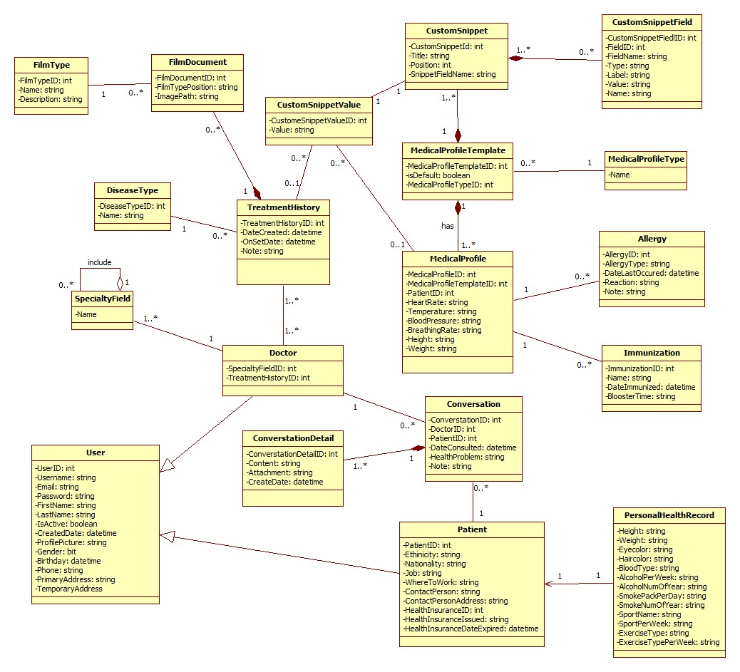

Figure 3: Class Diagram

## Sequence Diagram

### <Guest> Login



Figure 4: <Guest> Login Sequence Diagram

### <Guest> Register



Figure 5: <Guest> Register Sequence Diagram

### <Authorized User> Change Password



Figure 6: <Authorized User> Change Password Sequence Diagram

### <Authorized User> Change Profile Picture



Figure 7: <Authorized User> Change Profile Picture Sequence Diagram

### <Patient> Conversation



Figure 8: <Patient> Conversation Sequence Diagram

### <Doctor> Request Webcam



Figure 9: <Doctor> Request Webcam Sequence Diagram

### <Patient> Upload Attachment



Figure 10: <Patient> Upload Attachment

### <Admin> Define New Medical Profile Template



Figure 11 <Admin> Define New Medical Profile Template

### <Admin> Update Medical Profile Template



Figure 12 <Admin> Update Medical Profile Template

### <Doctor> Update Medical Profile

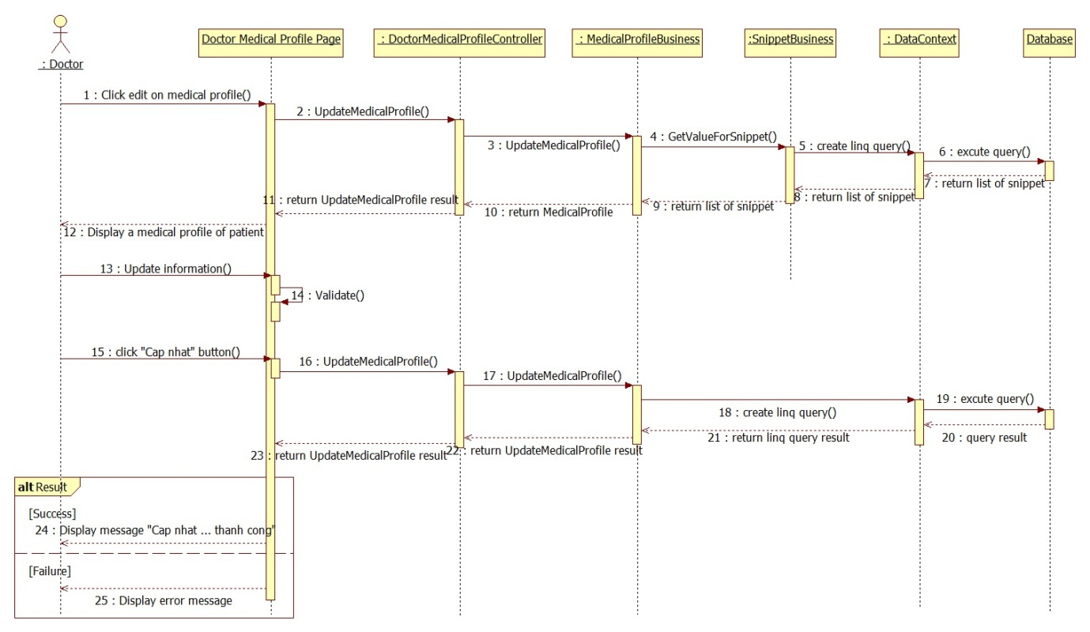

Figure 13: <Doctor> Update Medical Profile

### <Doctor> Views Medical Profile



Figure 14: <Doctor> Views Medical Profile

### <Patient> Update Personal Health Record



Figure 15: <Patient> Update Personal Health Record

### <Patient> View Medical Profile



Figure 9: <Patient> View Medical Profile Record

## User Interface Design

### HOMEPAGE SCREEN

#### Screen Images

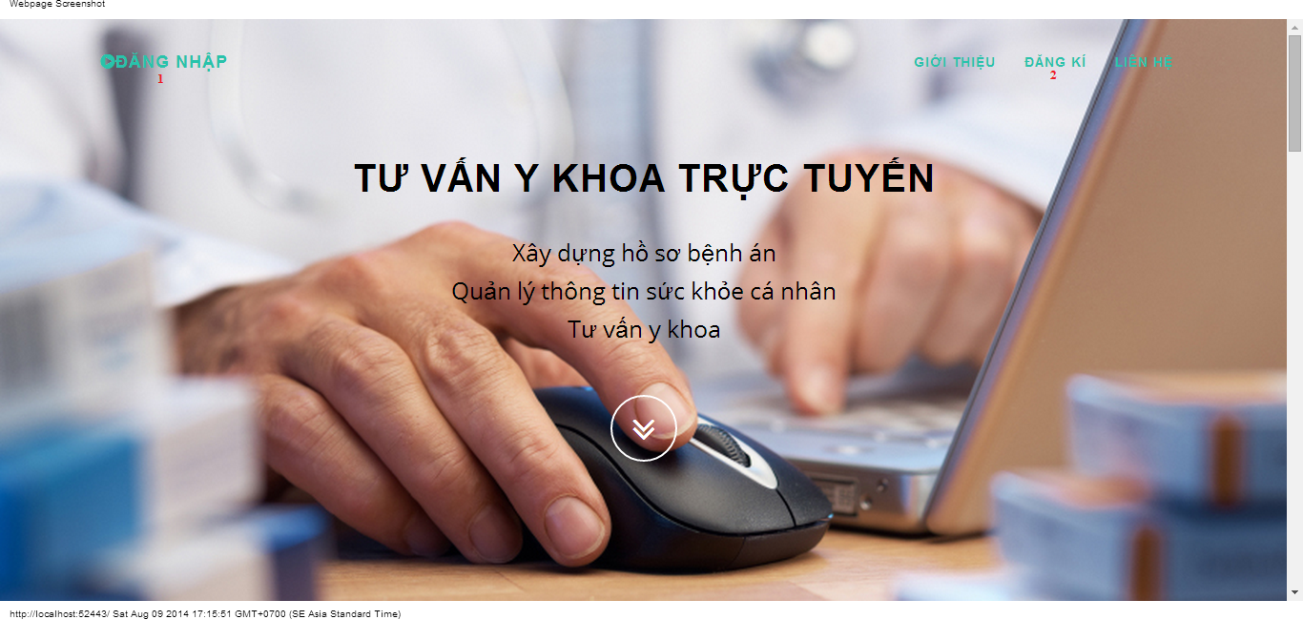

#### Objects and Actions

#### Data fields

|  |  |  |  |  |  |  |
| --- | --- | --- | --- | --- | --- | --- |
| **Field No** | **Field name** | **Type** | **Mandatory** | **Data type** | **Max length** | **Description** |

#### Actions

|  |  |  |  |  |  |
| --- | --- | --- | --- | --- | --- |
| **Field No** | **Field name** | **Type** | **Action** | **Description** | **Validation** |
| 1 | Đăng nhập | Link | On click | Forward to “Login” page |  |
| 2 | Đăng kí | Link | On click | Forward to “Register” page |  |

### LOGIN SCREEN

#### Screen image

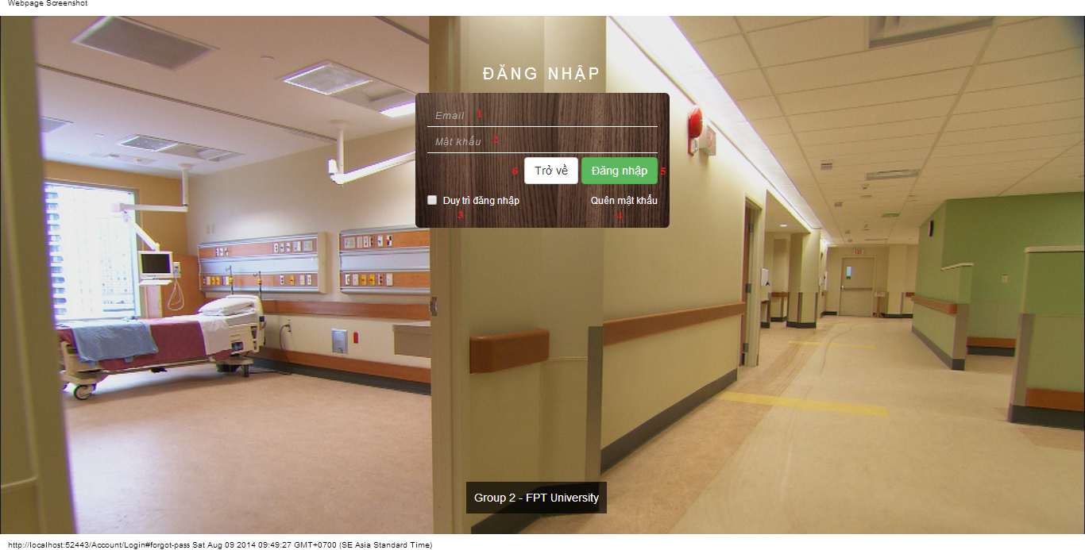

#### Objects and Actions

#### Data fields

|  |  |  |  |  |  |  |
| --- | --- | --- | --- | --- | --- | --- |
| **Field No** | **Field name** | **Type** | **Mandatory** | **Data type** | **Max length** | **Description** |
| 1 | Email | Textbox | Yes | String |  | Contain user’s email to login |
| 2 | Mật khẩu | Textbox | Yes | String |  | Contain user’s password to login |
| 3 | Duy trì đăng nhập | Checkbox | No | Boolean |  | Check to remember user to login again |

#### Actions

|  |  |  |  |  |  |
| --- | --- | --- | --- | --- | --- |
| **Field No** | **Field name** | **Type** | **Action** | **Description** | **Validation** |
| 4 | Quên mật khẩu | Link | On click | Forward to popup “ForgotPassword”. |  |
| 5 | Đăng nhập | Button | On click | Forward to page follow user’s role. | Email and password not empty |
| 6 | Trở về | Button | On click | Cancel the login. Back to previous page. |  |

### REGISTER SCREEN

#### Screen image

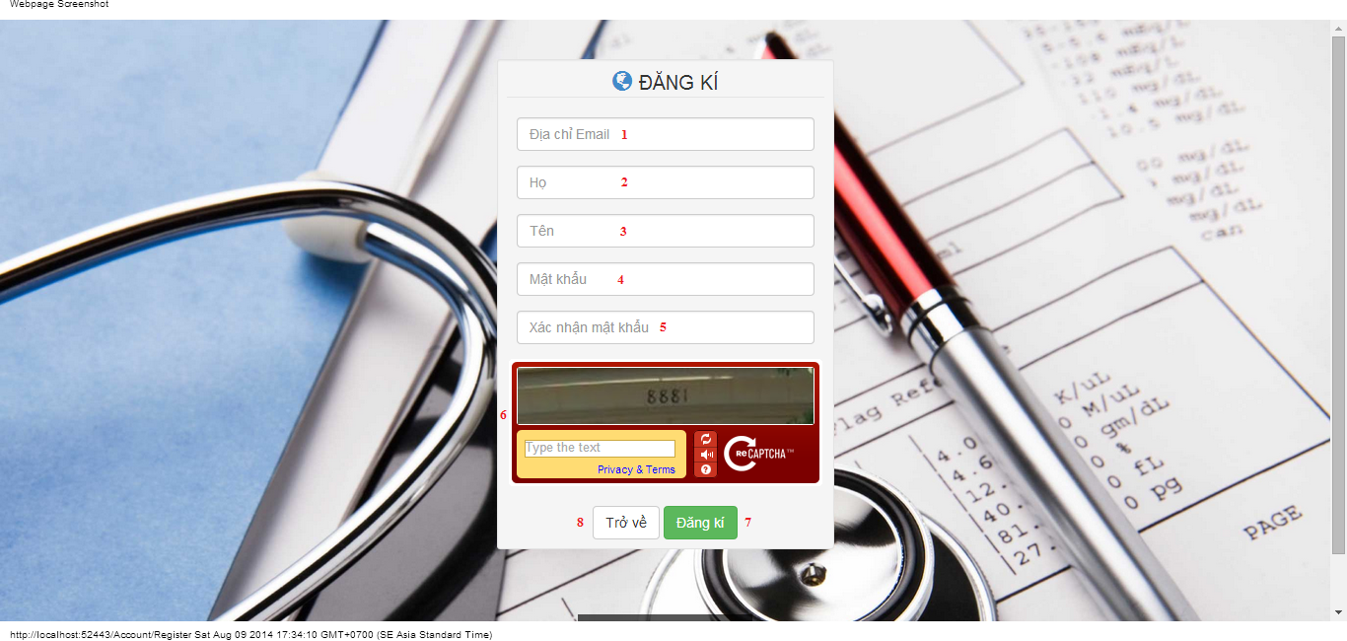

#### Objects and Actions

#### Data fields

|  |  |  |  |  |  |  |
| --- | --- | --- | --- | --- | --- | --- |
| **Field No** | **Field name** | **Type** | **Mandatory** | **Data type** | **Max length** | **Description** |
| 1 | Địa chỉ Email | Textbox | Yes | String | 50 | Contain user’s email to login |
| 2 | Họ | Textbox | Yes | String | 25 | Contain user’s last name |
| 3 | Tên | Textbox | Yes | String | 25 | Contain user’s first name |
| 4 | Mật khẩu | Textbox | Yes | String | 25 | Contain user’s password to login |
| 5 | Xác nhận mật khẩu | Textbox | Yes | String | 25 | Contain the confirm password |
| 6 | Retype Image | Textbox | Yes | String |  | Contain the verifying captcha |

#### Actions

|  |  |  |  |  |  |
| --- | --- | --- | --- | --- | --- |
| **Field No** | **Field name** | **Type** | **Action** | **Description** | **Validation** |
| 7 | Đăng kí | Button | On click | Submit inputted data to server | Inputted data must be valid |
| 8 | Trở về | Button | On click | Cancel the registration. Back to previous page |  |

### FORGOT PASSWORD SCREEN

#### Screen image

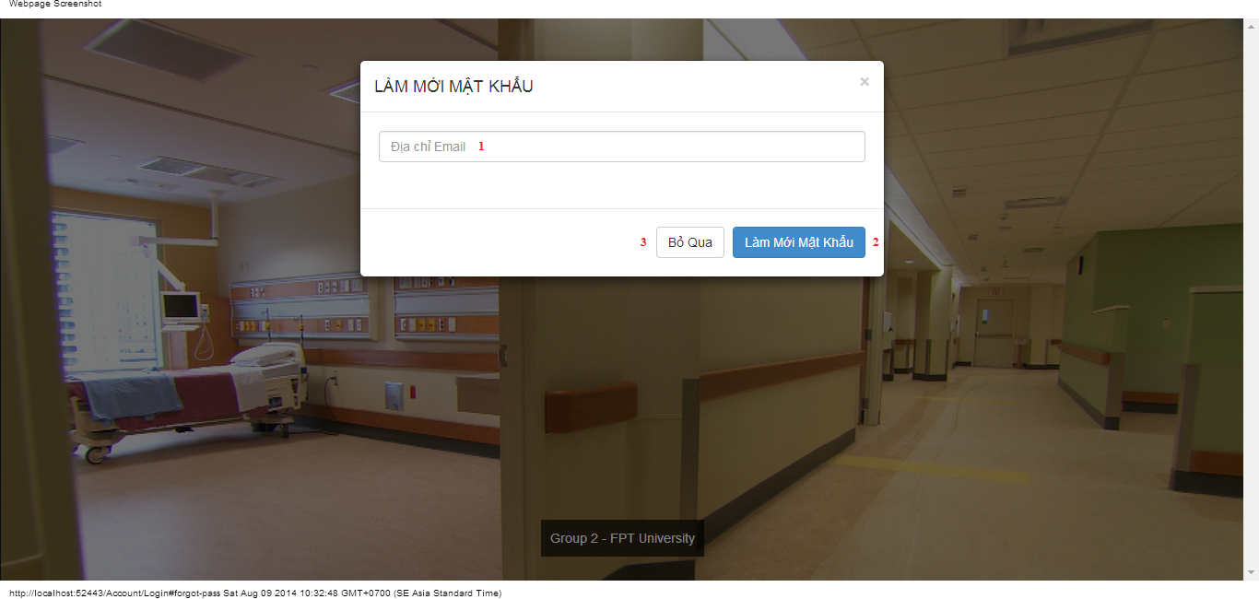

#### Objects and Actions

#### Data fields

|  |  |  |  |  |  |  |
| --- | --- | --- | --- | --- | --- | --- |
| **Field No** | **Field name** | **Type** | **Mandatory** | **Data type** | **Max length** | **Description** |
| 1 | Địa chỉ Email | Textbox | Yes | String |  | Contain user’s email to reset password |

#### Actions

|  |  |  |  |  |  |
| --- | --- | --- | --- | --- | --- |
| **Field No** | **Field name** | **Type** | **Action** | **Description** | **Validation** |
| 2 | Làm mới mật khẩu | Button | On click | Submit inputted data to server | Inputted data must be valid |
| 3 | Bỏ qua | Button | On click | Dismiss model. Back to login page |  |

### ADMIN HOSPITAL INFORMATION SCREEN

#### Screen image

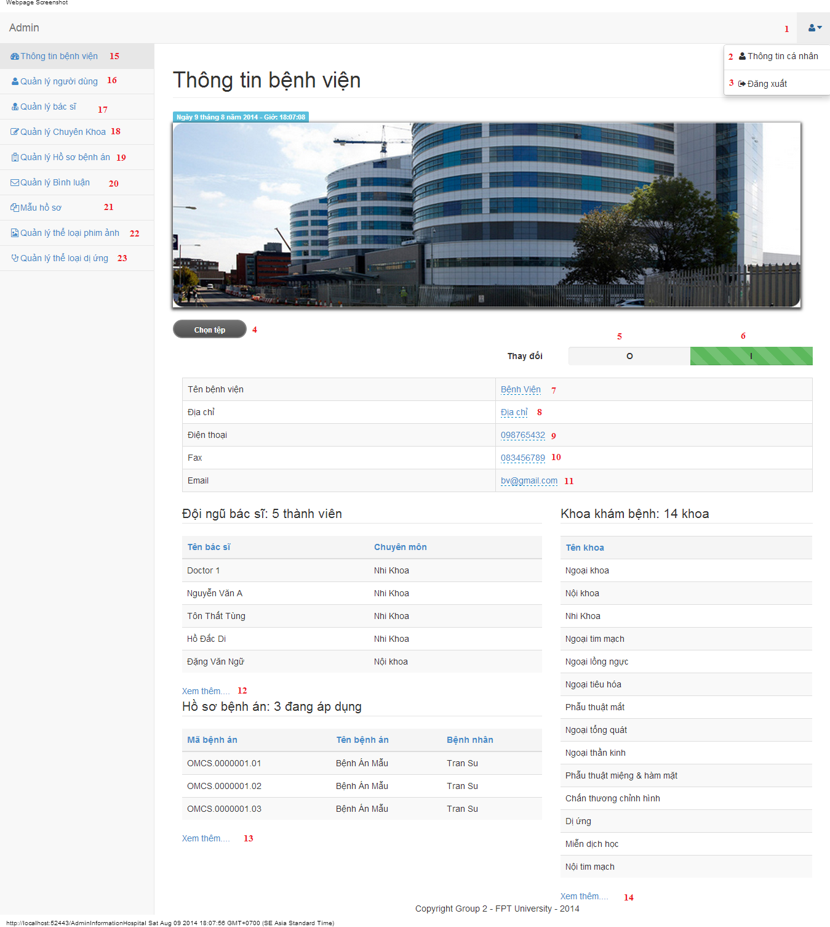

#### Objects and Actions

#### Data fields

|  |  |  |  |  |  |  |
| --- | --- | --- | --- | --- | --- | --- |
| **Field No** | **Field name** | **Type** | **Mandatory** | **Data type** | **Max length** | **Description** |
| 7 | Tên bệnh viện | Textbox | Yes | String | 50 | Contain hospital’s name |
| 8 | Địa chỉ | Textbox | Yes | String | 50 | Contain hospital’s address |
| 9 | Điện thoại | Textbox | Yes | String | 12 | Contain hospital’s phone |
| 10 | Fax | Textbox | Yes | String | 12 | Contain hospital’s fax |
| 11 | Email | Textbox | Yes | String | 50 | Contain hospital’s email |

#### Actions

|  |  |  |  |  |  |
| --- | --- | --- | --- | --- | --- |
| **Field No** | **Field name** | **Type** | **Action** | **Description** | **Validation** |
| 1 |  | DDL | On click | List “Thông tin cá nhân” and “Đăng xuất” |  |
| 2 | Thông tin cá nhân | Link | On click | Forward to “AdminInformation” page |  |
| 3 | Đăng xuất | Link | On click | Back to login page |  |
| 4 | Chọn tệp | File | On click | Submit inputted file to server |  |
| 5 | 0 | Checkbox | On click | Click “0” to view table hospital information |  |
| 6 | I | Checkbox | On click | Click “I” to edit table data hospital information |  |
| 12 | Xem thêm… | Link | On click | Forward to “AdminDoctor” page |  |
| 13 | Xem thêm… | Link | On click | Forward to “AdminMedicalProfile” page |  |
| 14 | Xem thêm… | Link | On click | Forward to “AdminSpecialtyField” page |  |
| 15 | Thông tin bệnh viện | Link | On click | Forward to “AdminInformationHospital” page |  |
| 16 | Quản lý người dùng | Link | On click | Forward to “AdminUser” page |  |
| 17 | Quản lý bác sĩ | Link | On click | Forward to “AdminDoctor” page |  |
| 18 | Quản lý chuyên khoa | Link | On click | Forward to “AdminSpecialtyField” page |  |
| 19 | Quản lý hồ sơ bệnh án | Link | On click | Forward to “AdminMedicalProfile” page |  |
| 20 | Quản lý bình luận | Link | On click | Forward to “AdminComment” page |  |
| 21 | Mẫu hồ sơ | Link | On click | Forward to “AdminTemplate” page |  |
| 22 | Quản lý thể loại phim ảnh | Link | On click | Forward to “FilmType” page |  |
| 23 | Quản lý thể loại dị ứng | Link | On click | Forward to “AllergyType” page |  |

### ADMIN INFORMATION SCREEN

#### Screen image

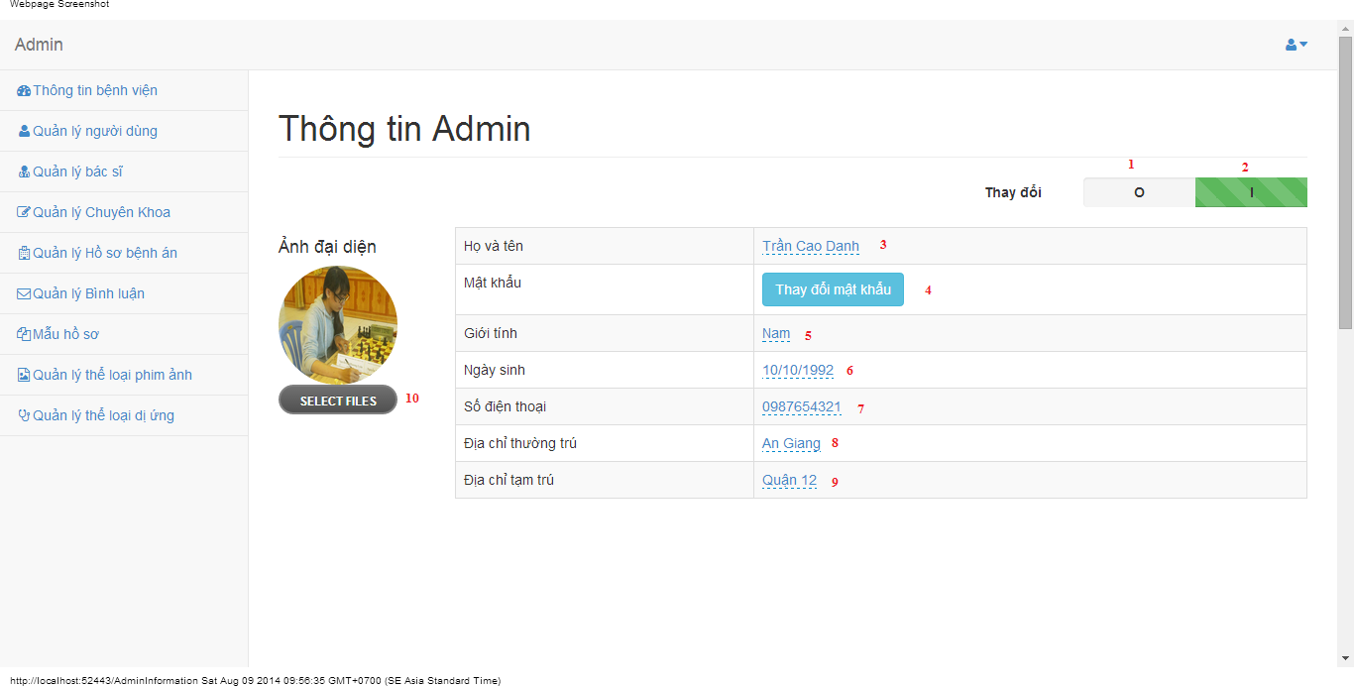

#### Objects and Actions

#### Data fields

|  |  |  |  |  |  |  |
| --- | --- | --- | --- | --- | --- | --- |
| **Field No** | **Field name** | **Type** | **Mandatory** | **Data type** | **Max length** | **Description** |
| 3 | Họ và tên | Textbox | Yes | String | 50 | Contain user’s full name |
| 5 | Giới tính | List | Yes | String | 50 | Contain user’s gender |
| 6 | Ngày sinh | Textbox | Yes | Date | 12 | Contain user’s birthday |
| 7 | Số điện thoại | Textbox | Yes | String | 12 | Contain user’s phone |
| 8 | Địa chỉ thường trú | Textbox | Yes | String | 50 | Contain user’s primary address |
| 9 | Địa chỉ tạm trú | Textbox | No | String | 50 | Contain user’s secondary address |

#### Actions

|  |  |  |  |  |  |
| --- | --- | --- | --- | --- | --- |
| **Field No** | **Field name** | **Type** | **Action** | **Description** | **Validation** |
| 1 | 0 | Checkbox | On click | Click “0” to view table admin information |  |
| 2 | I | Checkbox | On click | Click “I” to edit table data admin information |  |
| 4 | Thay đổi mật khẩu | Button | On click | Forward to popup “ChangePassword” |  |
| 10 | Chọn tệp | File | On click | Submit inputted file to server |  |

### MANAGE USERS SCREEN

#### Screen image

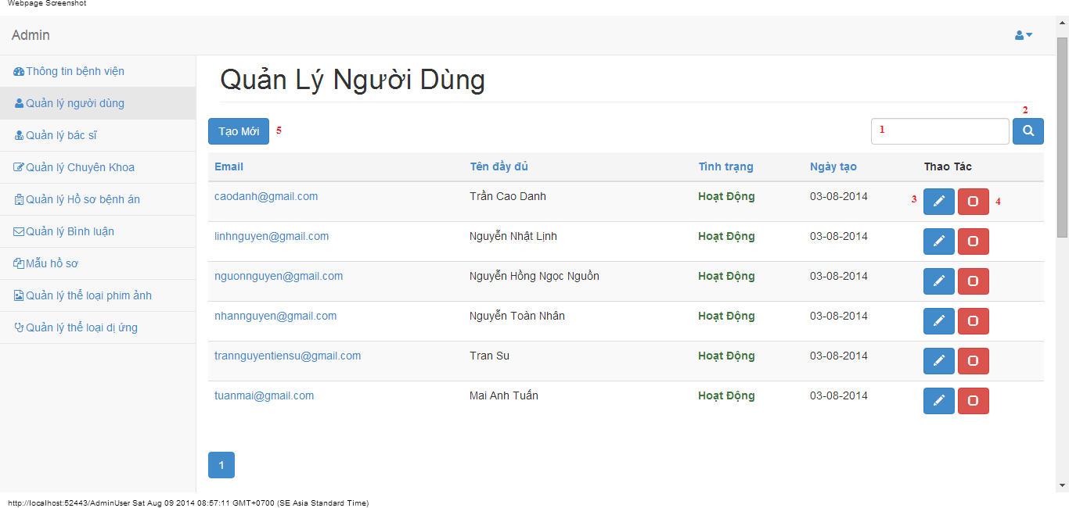

#### Objects and Actions

#### Data fields

|  |  |  |  |  |  |  |
| --- | --- | --- | --- | --- | --- | --- |
| **Field No** | **Field name** | **Type** | **Mandatory** | **Data type** | **Max length** | **Description** |
| 1 | Search | Textbox | No | String | 50 | Contain search condition to find some user account |

#### Actions

|  |  |  |  |  |  |
| --- | --- | --- | --- | --- | --- |
| **Field No** | **Field name** | **Type** | **Action** | **Description** | **Validation** |
| 2 | Tìm | Button | On click | Send inputted search condition to server |  |
| 3 | Cập nhật | Button | On click | Forward to popup “Edit” |  |
| 4 | Vô hiệu/Kích hoạt | Link | On click | Deactivate user or Activate user |  |
| 5 | Tạo mới | Button | On click | Forward to popup “Create” |  |

### CREATE USER SCREEN

#### Screen image

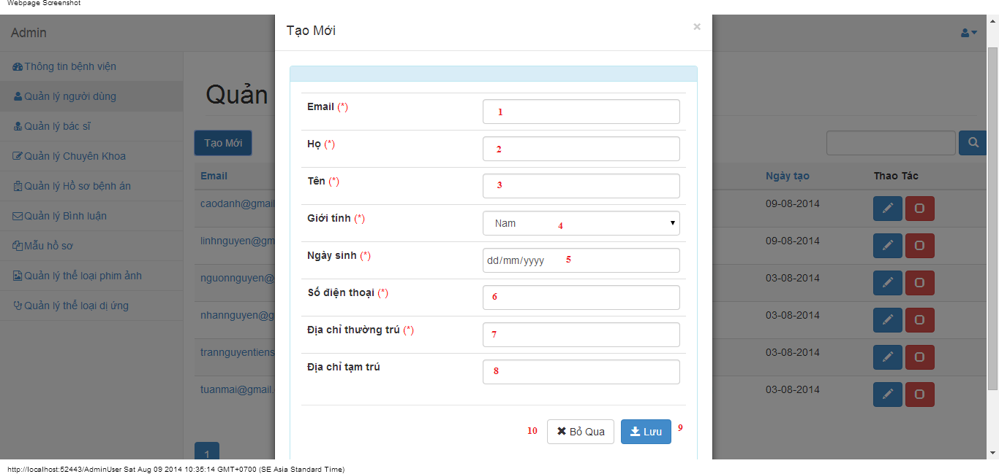

#### Objects and Actions

#### Data fields

|  |  |  |  |  |  |  |
| --- | --- | --- | --- | --- | --- | --- |
| **Field No** | **Field name** | **Type** | **Mandatory** | **Data type** | **Max length** | **Description** |
| 1 | Email | Textbox | Yes | String | 50 | Contain user’s email |
| 2 | Họ | Textbox | Yes | String | 50 | Contain user’s last name |
| 3 | Tên | Textbox | Yes | String | 50 | Contain user’s first name |
| 4 | Giới tính | Textbox | Yes | String |  | Contain user’s gender |
| 5 | Ngày sinh | Textbox | Yes | Date |  | Contain user’s birthday |
| 6 | Số điện thoại | Textbox | Yes | String | 12 | Contain user’s phone |
| 7 | Địa chỉ thường trú | Textbox | Yes | String | 50 | Contain user’s primary address |
| 8 | Địa chỉ tạm trú | Textbox | No | String | 50 | Contain user’s secondary address |

#### Actions

|  |  |  |  |  |  |
| --- | --- | --- | --- | --- | --- |
| **Field No** | **Field name** | **Type** | **Action** | **Description** | **Validation** |
| 9 | Lưu | Button | On click | Submit inputted data to server | Inputted data must be valid |
| 10 | Bỏ qua | Button | On click | Dismiss popup |  |

### EDIT USER SCREEN

#### Screen image

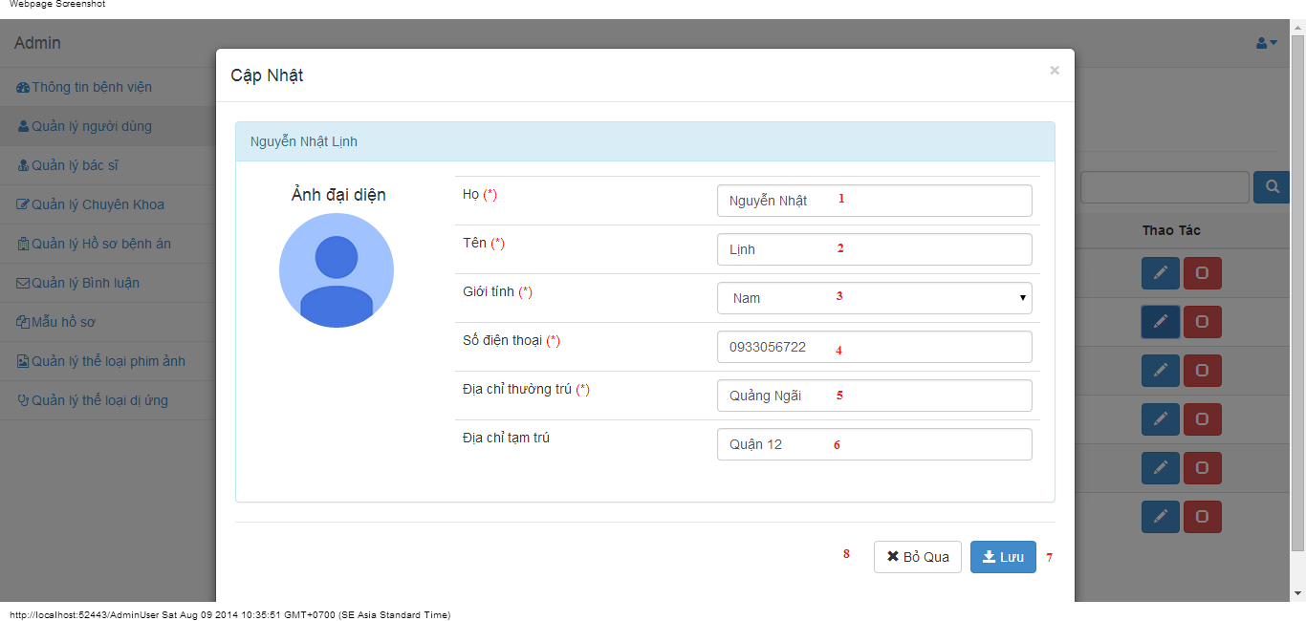

#### Objects and Actions

#### Data fields

|  |  |  |  |  |  |  |
| --- | --- | --- | --- | --- | --- | --- |
| **Field No** | **Field name** | **Type** | **Mandatory** | **Data type** | **Max length** | **Description** |
| 1 | Họ | Textbox | Yes | String | 50 | Contain user’s last name |
| 2 | Tên | Textbox | Yes | String | 50 | Contain user’s first name |
| 3 | Giới tính | Textbox | Yes | String |  | Contain user’s gender |
| 4 | Số điện thoại | Textbox | Yes | String | 12 | Contain user’s phone |
| 5 | Địa chỉ thường trú | Textbox | Yes | String | 50 | Contain user’s primary address |
| 6 | Địa chỉ tạm trú | Textbox | No | String | 50 | Contain user’s secondary address |

#### Actions

|  |  |  |  |  |  |
| --- | --- | --- | --- | --- | --- |
| **Field No** | **Field name** | **Type** | **Action** | **Description** | **Validation** |
| 7 | Lưu | Button | On click | Submit inputted data to server | Inputted data must be valid |
| 8 | Bỏ qua | Button | On click | Dismiss popup |  |

### MANAGE DOCTORS SCREEN

#### Screen image

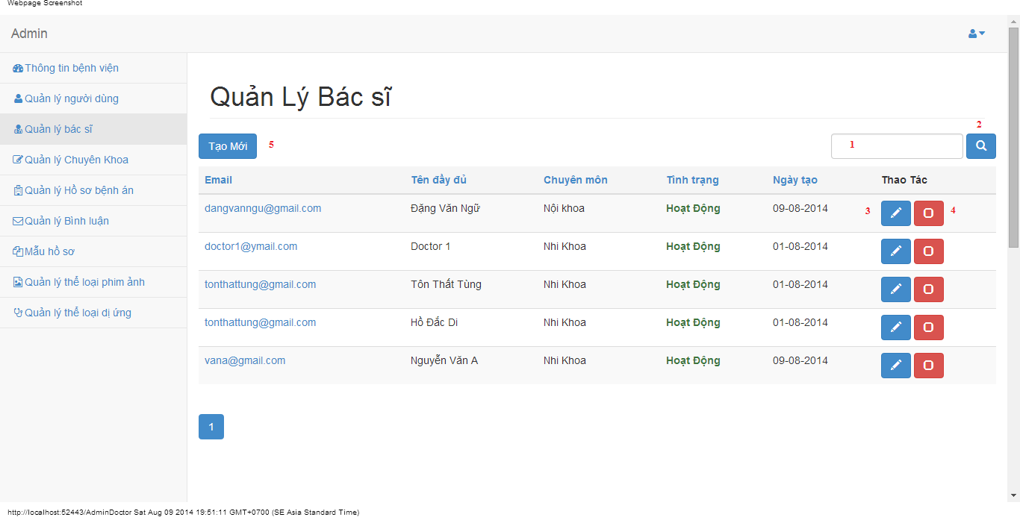

#### Objects and Actions

#### Data fields

|  |  |  |  |  |  |  |
| --- | --- | --- | --- | --- | --- | --- |
| **Field No** | **Field name** | **Type** | **Mandatory** | **Data type** | **Max length** | **Description** |
| 1 | Search | Textbox | No | String | 50 | Contain search condition to find some user account |

#### Actions

|  |  |  |  |  |  |
| --- | --- | --- | --- | --- | --- |
| **Field No** | **Field name** | **Type** | **Action** | **Description** | **Validation** |
| 2 | Tìm | Button | On click | Send inputted search condition to server |  |
| 3 | Cập nhật | Button | On click | Forward to popup “Edit” |  |
| 4 | Vô hiệu/Kích hoạt | Link | On click | Deactivate user or Activate user |  |
| 5 | Tạo mới | Button | On click | Forward to popup “Create” |  |

### CREATE DOCTOR SCREEN

#### Screen image

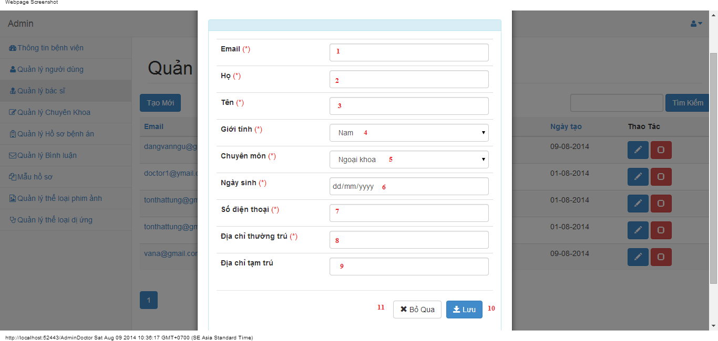

#### Objects and Actions

#### Data fields

|  |  |  |  |  |  |  |
| --- | --- | --- | --- | --- | --- | --- |
| **Field No** | **Field name** | **Type** | **Mandatory** | **Data type** | **Max length** | **Description** |
| 1 | Email | Textbox | Yes | String | 50 | Contain user’s email |
| 2 | Họ | Textbox | Yes | String | 50 | Contain user’s last name |
| 3 | Tên | Textbox | Yes | String | 50 | Contain user’s first name |
| 4 | Giới tính | Textbox | Yes | String |  | Contain user’s gender |
| 5 | Chuyên môn | DDL | Yes | String |  | Contain user’s specialty field |
| 6 | Ngày sinh | Textbox | Yes | Date |  | Contain user’s birthday |
| 7 | Số điện thoại | Textbox | Yes | String | 12 | Contain user’s phone |
| 8 | Địa chỉ thường trú | Textbox | Yes | String | 50 | Contain user’s primary address |
| 9 | Địa chỉ tạm trú | Textbox | No | String | 50 | Contain user’s secondary address |

#### Actions

|  |  |  |  |  |  |
| --- | --- | --- | --- | --- | --- |
| **Field No** | **Field name** | **Type** | **Action** | **Description** | **Validation** |
| 9 | Lưu | Button | On click | Submit inputted data to server |  |
| 10 | Bỏ qua | Button | On click | Dismiss popup |  |

### EDIT DOCTOR SCREEN

#### Screen image

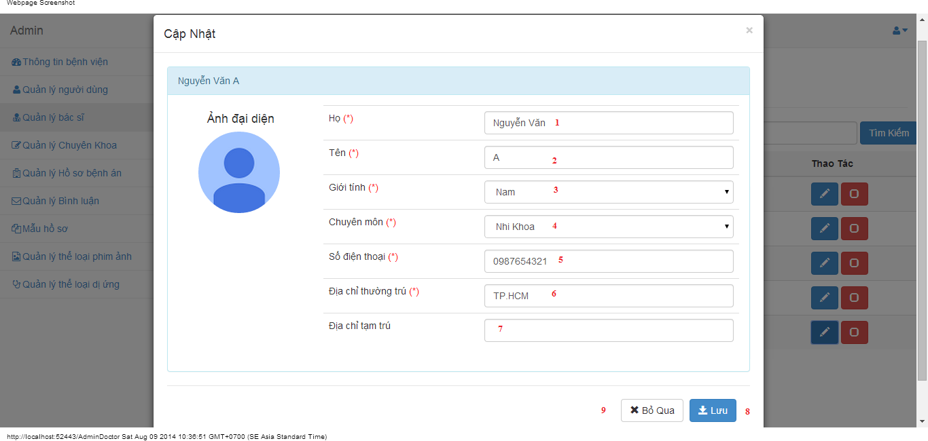

#### Objects and Actions

#### Data fields

|  |  |  |  |  |  |  |
| --- | --- | --- | --- | --- | --- | --- |
| **Field No** | **Field name** | **Type** | **Mandatory** | **Data type** | **Max length** | **Description** |
| 1 | Họ | Textbox | Yes | String | 50 | Contain user’s last name |
| 2 | Tên | Textbox | Yes | String | 50 | Contain user’s first name |
| 3 | Giới tính | Textbox | Yes | String |  | Contain user’s gender |
| 4 | Chuyên môn | DDL | Yes | String |  | Contain user’s specialty field |
| 5 | Số điện thoại | Textbox | Yes | String | 12 | Contain user’s phone |
| 6 | Địa chỉ thường trú | Textbox | Yes | String | 50 | Contain user’s primary address |
| 7 | Địa chỉ tạm trú | Textbox | No | String | 50 | Contain user’s secondary address |

#### Actions

|  |  |  |  |  |  |
| --- | --- | --- | --- | --- | --- |
| **Field No** | **Field name** | **Type** | **Action** | **Description** | **Validation** |
| 7 | Lưu | Button | On click | Submit inputted data to server | Inputted data must be valid |
| 8 | Bỏ qua | Button | On click | Dismiss popup |  |

### MANAGE SPECIALTY FIELDS SCREEN

#### Screen image

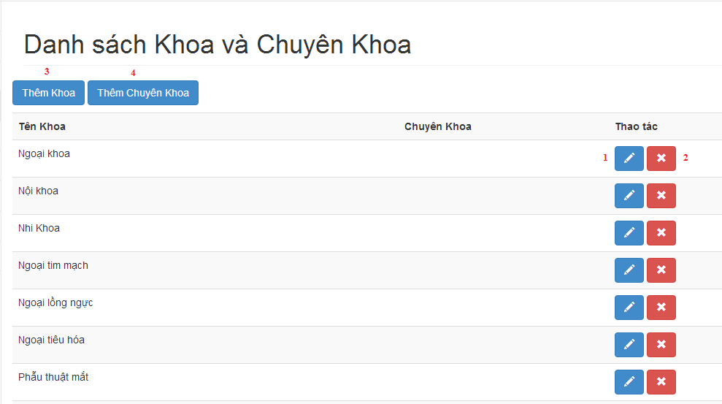

#### Objects and Actions

#### Data fields

|  |  |  |  |  |  |  |
| --- | --- | --- | --- | --- | --- | --- |
| **Field No** | **Field name** | **Type** | **Mandatory** | **Data type** | **Max length** | **Description** |

#### Actions

|  |  |  |  |  |  |
| --- | --- | --- | --- | --- | --- |
| **Field No** | **Field name** | **Type** | **Action** | **Description** | **Validation** |
| 1 | Cập nhật | Button | On click | Forward to popup “Edit” |  |
| 2 | Xóa | Button | On click | Delete a specialty field |  |
| 3 | Thêm khoa | Button | On click | Forward to popup “Create” |  |
| 4 | Thêm chuyên khoa | Button | On click | Forward to popup “Create” |  |

### CREATE SPECIALTY FIELD SCREEN

#### Screen image

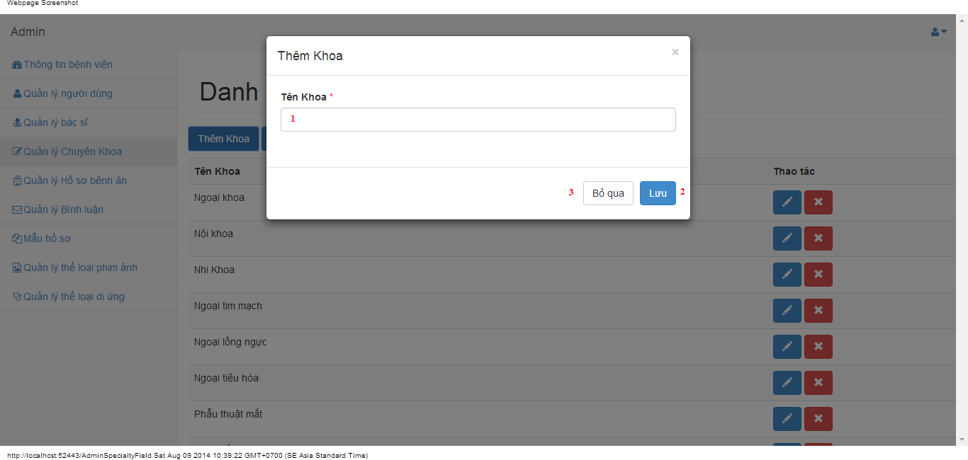

#### Objects and Actions

#### Data fields

|  |  |  |  |  |  |  |
| --- | --- | --- | --- | --- | --- | --- |
| **Field No** | **Field name** | **Type** | **Mandatory** | **Data type** | **Max length** | **Description** |
| 1 | Tên khoa | Textbox | Yes | String | 50 | Contain specialty field |

#### Actions

|  |  |  |  |  |  |
| --- | --- | --- | --- | --- | --- |
| **Field No** | **Field name** | **Type** | **Action** | **Description** | **Validation** |
| 9 | Lưu | Button | On click | Submit inputted data to server | Inputted data must be valid |
| 10 | Bỏ qua | Button | On click | Dismiss popup |  |

### CREATE SPECIALTY FIELD SCREEN

#### Screen image

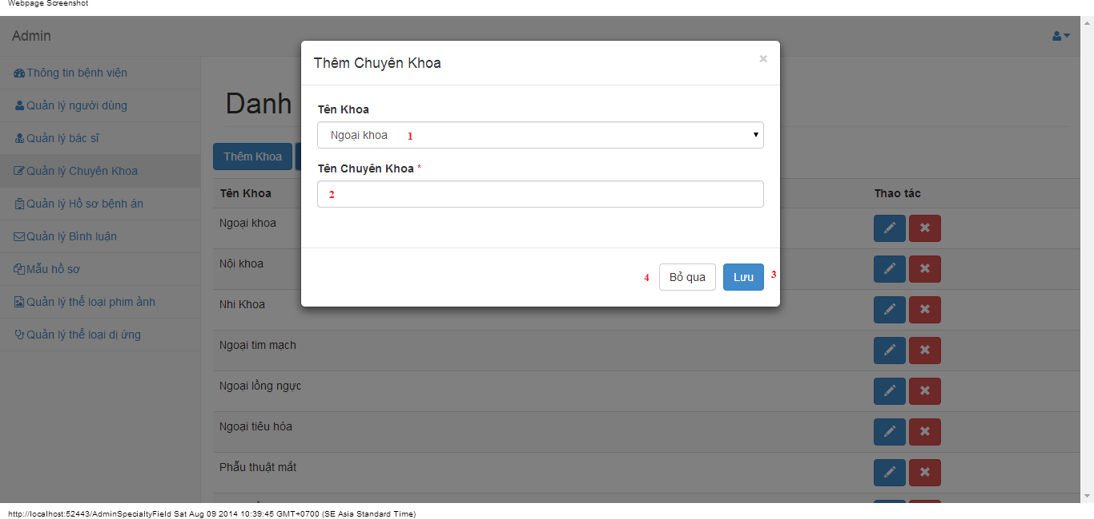

#### Objects and Actions

#### Data fields

|  |  |  |  |  |  |  |
| --- | --- | --- | --- | --- | --- | --- |
| **Field No** | **Field name** | **Type** | **Mandatory** | **Data type** | **Max length** | **Description** |
| 1 | Tên Khoa | DDL | Yes | String | 50 | Contain parent specialty fields |
| 2 | Tên Chuyên Khoa | Textbox | Yes | String | 50 | Contain specialty field |

#### Actions

|  |  |  |  |  |  |
| --- | --- | --- | --- | --- | --- |
| **Field No** | **Field name** | **Type** | **Action** | **Description** | **Validation** |
| 7 | Lưu | Button | On click | Submit inputted data to server | Inputted data must be valid |
| 8 | Bỏ qua | Button | On click | Dismiss popup |  |

### EDIT SPECIALTY FIELD SCREEN

#### Screen image

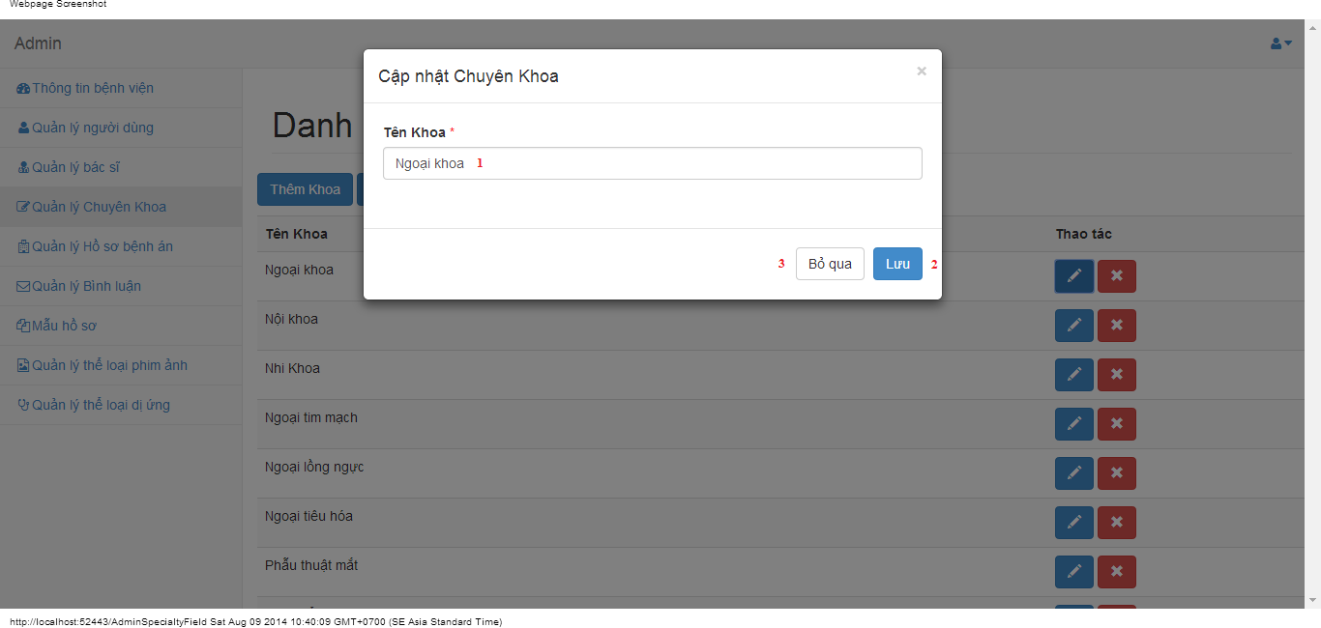

#### Objects and Actions

#### Data fields

|  |  |  |  |  |  |  |
| --- | --- | --- | --- | --- | --- | --- |
| **Field No** | **Field name** | **Type** | **Mandatory** | **Data type** | **Max length** | **Description** |
| 1 | Tên khoa | Textbox | Yes | String | 50 | Contain specialty field |

#### Actions

|  |  |  |  |  |  |
| --- | --- | --- | --- | --- | --- |
| **Field No** | **Field name** | **Type** | **Action** | **Description** | **Validation** |
| 9 | Lưu | Button | On click | Submit inputted data to server | Inputted data must be valid |
| 10 | Bỏ qua | Button | On click | Dismiss popup |  |

### EDIT SPECIALTY FIELD SCREEN

#### Screen image

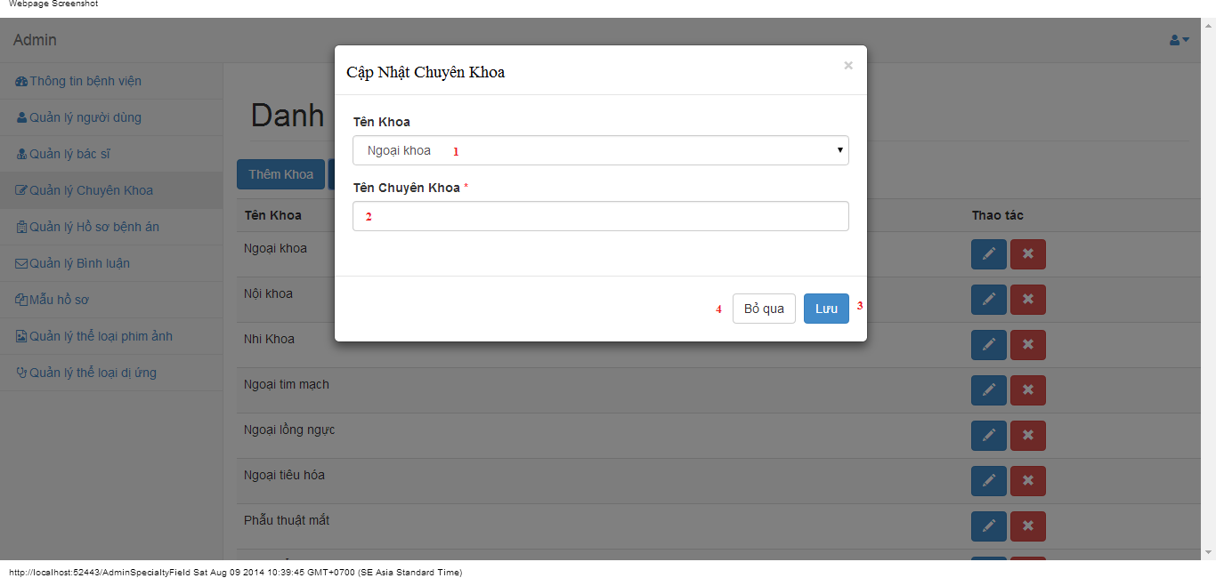

#### Objects and Actions

#### Data fields

|  |  |  |  |  |  |  |
| --- | --- | --- | --- | --- | --- | --- |
| **Field No** | **Field name** | **Type** | **Mandatory** | **Data type** | **Max length** | **Description** |
| 1 | Tên Khoa | DDL | Yes | String | 50 | Contain parent specialty fields |
| 2 | Tên Chuyên Khoa | Textbox | Yes | String | 50 | Contain specialty field |

#### Actions

|  |  |  |  |  |  |
| --- | --- | --- | --- | --- | --- |
| **Field No** | **Field name** | **Type** | **Action** | **Description** | **Validation** |
| 7 | Lưu | Button | On click | Submit inputted data to server | Inputted data must be valid |
| 8 | Bỏ qua | Button | On click | Dismiss popup |  |

### MANAGE MEDICAL PROFILES SCREEN

#### Screen image

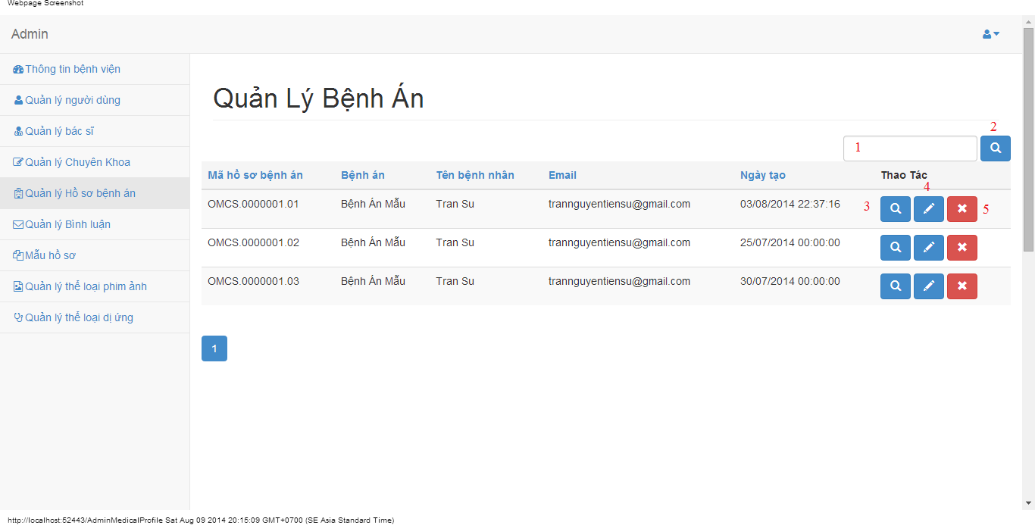

#### Objects and Actions

#### Data fields

|  |  |  |  |  |  |  |
| --- | --- | --- | --- | --- | --- | --- |
| **Field No** | **Field name** | **Type** | **Mandatory** | **Data type** | **Max length** | **Description** |
| 1 | Search | Textbox | No | String | 50 | Contain search condition to find some medical profile |

#### Actions

|  |  |  |  |  |  |
| --- | --- | --- | --- | --- | --- |
| **Field No** | **Field name** | **Type** | **Action** | **Description** | **Validation** |
| 2 | Tìm | Button | On click | Send inputted search condition to server |  |
| 3 | Xem chi tiết | Button | On click | Forward to “Details” page |  |
| 4 | Cập nhật | Link | On click | Forward to “UpdateMedicalProfile” page |  |
| 5 | Xóa | Button | On click | Delete a medical profile |  |

### VIEW MEDICAL PROFILE SCREEN

#### Screen image

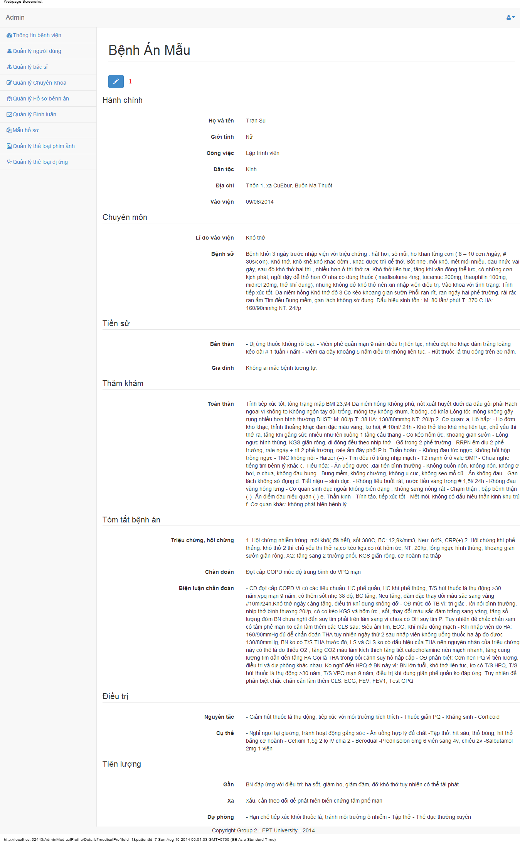

#### Objects and Actions

#### Data fields

|  |  |  |  |  |  |  |
| --- | --- | --- | --- | --- | --- | --- |
| **Field No** | **Field name** | **Type** | **Mandatory** | **Data type** | **Max length** | **Description** |

#### Actions

|  |  |  |  |  |  |
| --- | --- | --- | --- | --- | --- |
| **Field No** | **Field name** | **Type** | **Action** | **Description** | **Validation** |
| 1 | Cập nhật | Link | On click | Forward to “UpdateMedicalProfile” page |  |

### UPDATE MEDICAL PROFILE SCREEN

#### Screen image

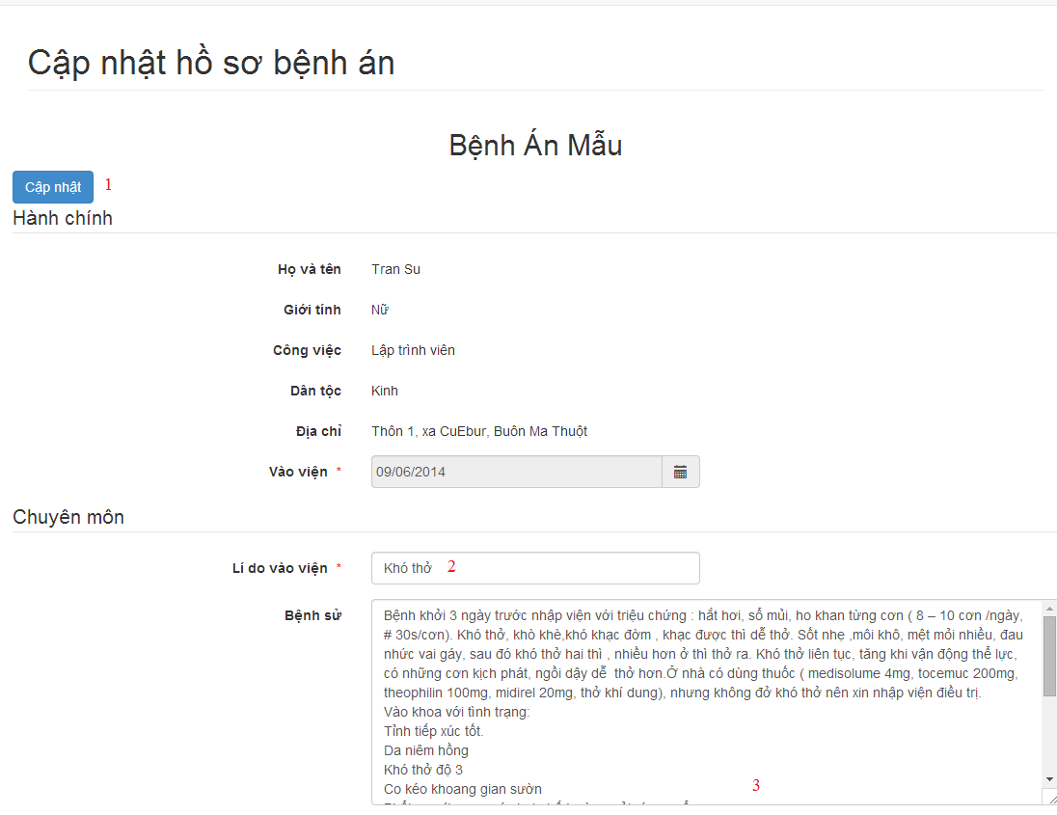

#### Objects and Actions

#### Data fields

|  |  |  |  |  |  |  |
| --- | --- | --- | --- | --- | --- | --- |
| **Field No** | **Field name** | **Type** | **Mandatory** | **Data type** | **Max length** | **Description** |
| 2 | Lí do vào viện | Textbox | Yes | String |  | Contain input follow medical profile template |
| 3 | Bệnh sử | Textbox | Yes | String |  | Contain input follow medical profile template |

#### Actions

|  |  |  |  |  |  |
| --- | --- | --- | --- | --- | --- |
| **Field No** | **Field name** | **Type** | **Action** | **Description** | **Validation** |
| 1 | Cập nhật | Link | On click | Submit inputted data to server |  |

### MANAGE MEDICAL PROFILES SCREEN

#### Screen image

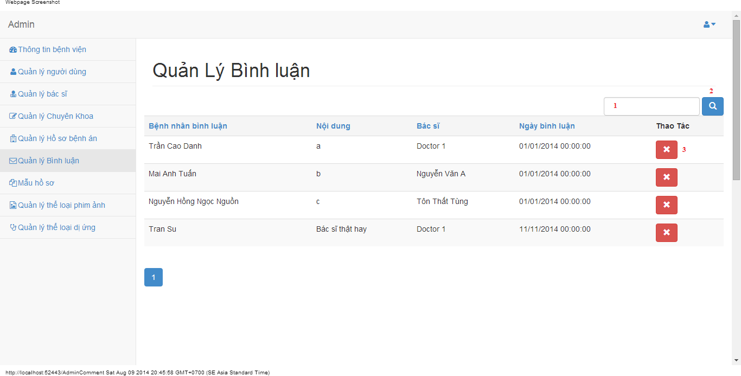

#### Objects and Actions

#### Data fields

|  |  |  |  |  |  |  |
| --- | --- | --- | --- | --- | --- | --- |
| **Field No** | **Field name** | **Type** | **Mandatory** | **Data type** | **Max length** | **Description** |
| 1 | Search | Textbox | No | String | 50 | Contain search condition to find some user account |

#### Actions

|  |  |  |  |  |  |
| --- | --- | --- | --- | --- | --- |
| **Field No** | **Field name** | **Type** | **Action** | **Description** | **Validation** |
| 2 | Tìm | Button | On click | Send inputted search condition to server |  |
| 3 | Xóa | Button | On click | Delete a comment |  |

### MANAGE MEDICAL PROFILE TEMPLATES SCREEN

#### Screen image

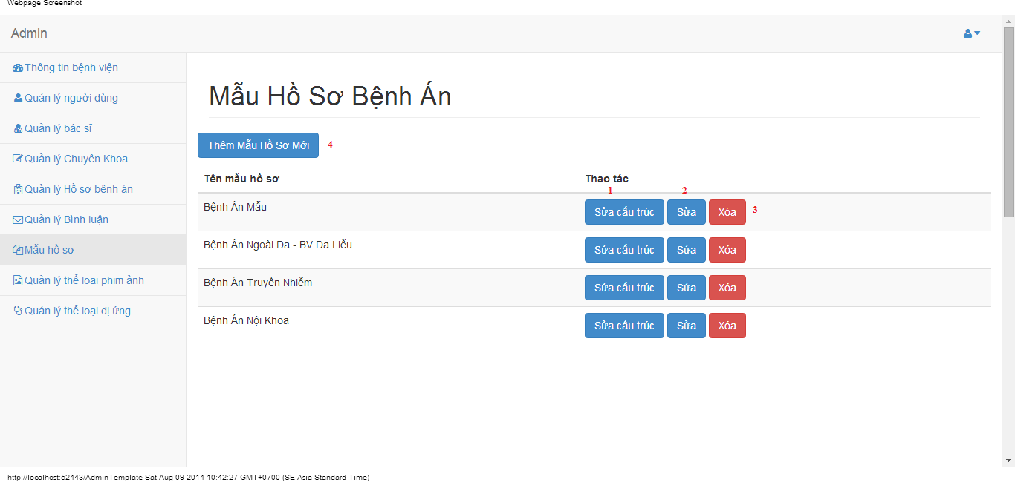

#### Objects and Actions

#### Data fields

|  |  |  |  |  |  |  |
| --- | --- | --- | --- | --- | --- | --- |
| **Field No** | **Field name** | **Type** | **Mandatory** | **Data type** | **Max length** | **Description** |

#### Actions

|  |  |  |  |  |  |
| --- | --- | --- | --- | --- | --- |
| **Field No** | **Field name** | **Type** | **Action** | **Description** | **Validation** |
| 1 | Sửa cấu trúc | Button | On click | Forward to “Editor” page |  |
| 2 | Sửa | Button | On click | Forward to popup “Edit” |  |
| 3 | Xóa | Button | On click | Delete a medical profile template |  |
| 4 | Thêm mẫu hồ sơ mới | Button | On click | Forward to popup “Create” |  |

### EDIT MEDICAL PROFILE TEMPLATES SCREEN

#### Screen image

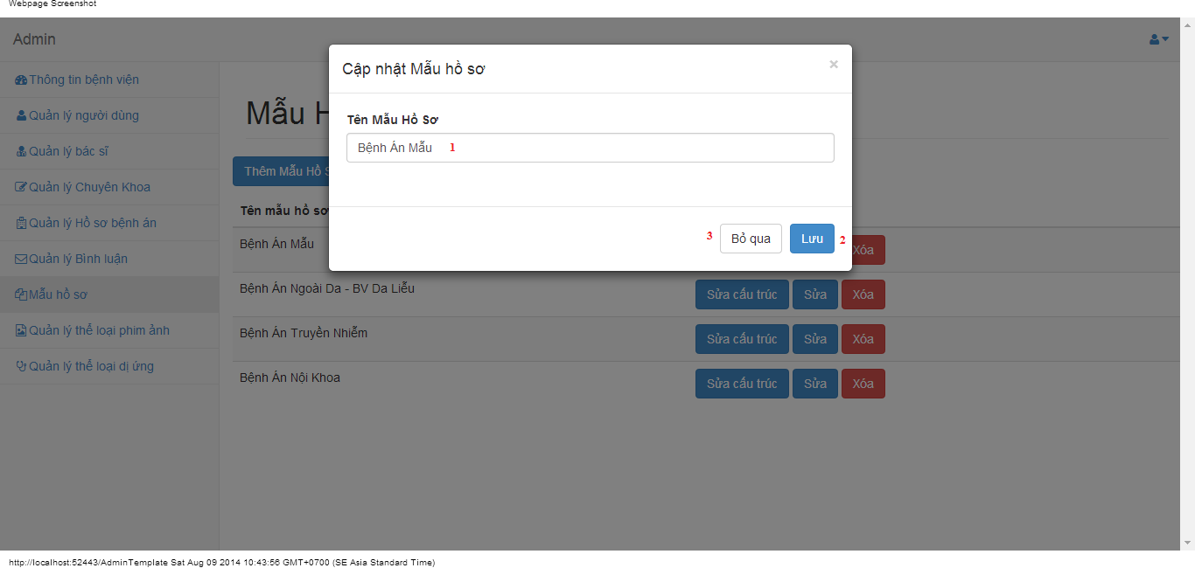

#### Objects and Actions

#### Data fields

|  |  |  |  |  |  |  |
| --- | --- | --- | --- | --- | --- | --- |
| **Field No** | **Field name** | **Type** | **Mandatory** | **Data type** | **Max length** | **Description** |
| 1 | Tên mẫu hồ sơ | Textbox | Yes | String | 50 | Contain name medical profile |

#### Actions

|  |  |  |  |  |  |
| --- | --- | --- | --- | --- | --- |
| **Field No** | **Field name** | **Type** | **Action** | **Description** | **Validation** |
| 9 | Lưu | Button | On click | Submit inputted data to server | Inputted data must be valid |
| 10 | Bỏ qua | Button | On click | Dismiss popup |  |

### ADD MEDICAL PROFILE TEMPLATES SCREEN

#### Screen image

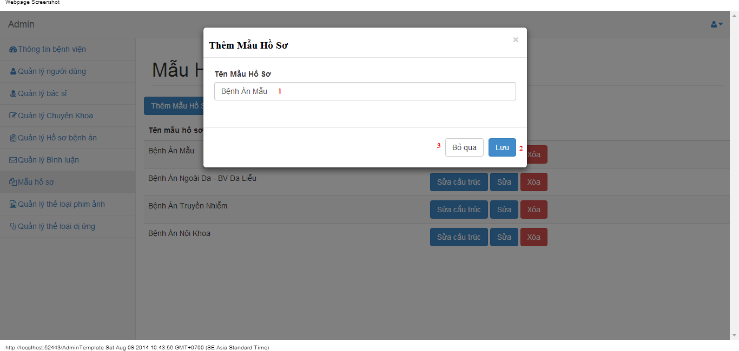

#### Objects and Actions

#### Data fields

|  |  |  |  |  |  |  |
| --- | --- | --- | --- | --- | --- | --- |
| **Field No** | **Field name** | **Type** | **Mandatory** | **Data type** | **Max length** | **Description** |
| 1 | Tên mẫu hồ sơ | Textbox | Yes | String | 50 | Contain name medical profile |

#### Actions

|  |  |  |  |  |  |
| --- | --- | --- | --- | --- | --- |
| **Field No** | **Field name** | **Type** | **Action** | **Description** | **Validation** |
| 9 | Lưu | Button | On click | Submit inputted data to server | Inputted data must be valid |
| 10 | Bỏ qua | Button | On click | Dismiss popup |  |

### EDITOR/UPDATE MEDICAL PROFILE TEMPLATES SCREEN

#### Screen image

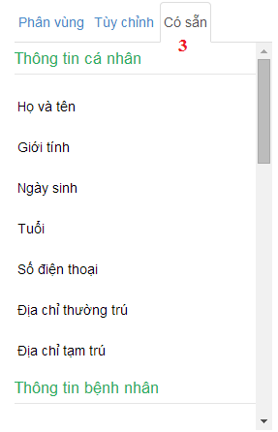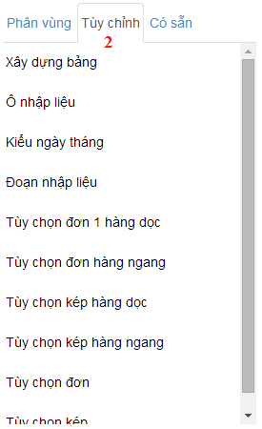 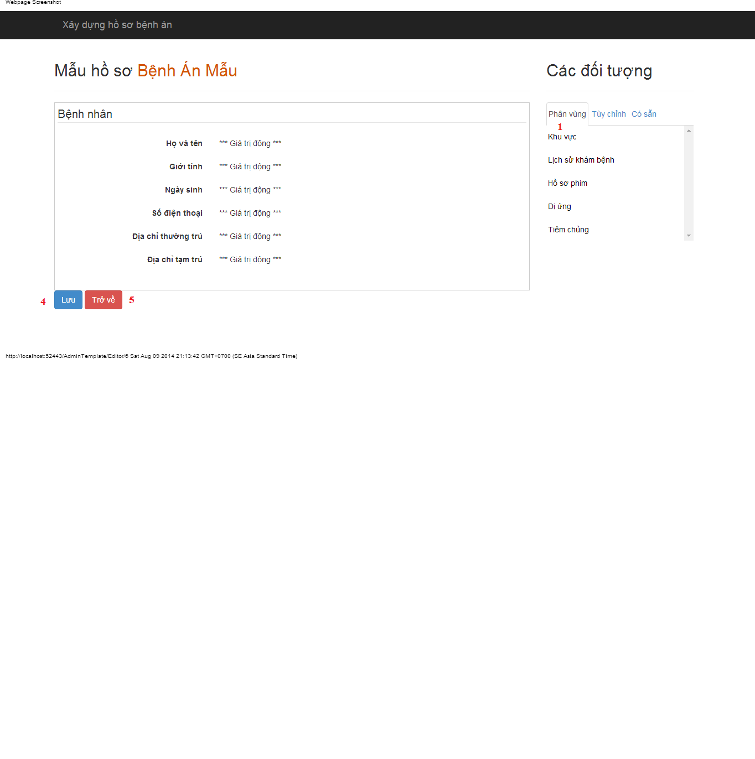

#### Objects and Actions

#### Data fields

|  |  |  |  |  |  |  |
| --- | --- | --- | --- | --- | --- | --- |
| **Field No** | **Field name** | **Type** | **Mandatory** | **Data type** | **Max length** | **Description** |

#### Actions

|  |  |  |  |  |  |
| --- | --- | --- | --- | --- | --- |
| **Field No** | **Field name** | **Type** | **Action** | **Description** | **Validation** |
| 1 | Phân vùng | Link | On click | Drag data to create/update medical profile template |  |
| 2 | Tùy chỉnh | Link | On click | Dismiss popup |  |
| 3 | Có sẵn | Link | On click | Drag data to create/update medical profile template |  |
| 4 | Lưu | Button | On click | Submit inputted data to server |  |
| 5 | Trở về | Button | On click | Back to previous page |  |

### MANAGE FILM TYPES SCREEN

#### Screen image

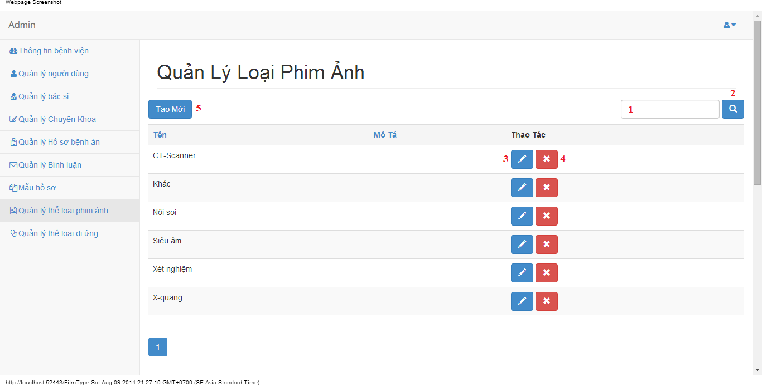

#### Objects and Actions

#### Data fields

|  |  |  |  |  |  |  |
| --- | --- | --- | --- | --- | --- | --- |
| **Field No** | **Field name** | **Type** | **Mandatory** | **Data type** | **Max length** | **Description** |
| 1 | Search | Textbox | No | String | 50 | Contain search condition to find some film type |

#### Actions

|  |  |  |  |  |  |
| --- | --- | --- | --- | --- | --- |
| **Field No** | **Field name** | **Type** | **Action** | **Description** | **Validation** |
| 2 | Tìm | Button | On click | Send inputted search condition to server |  |
| 3 | Cập nhật | Button | On click | Forward to “Edit” page |  |
| 4 | Xóa | Button | On click | Delete a film type |  |
| 5 | Tạo mới | Button | On click | Forward to “Create” page |  |

### CREATE FILM TYPE SCREEN

#### Screen image

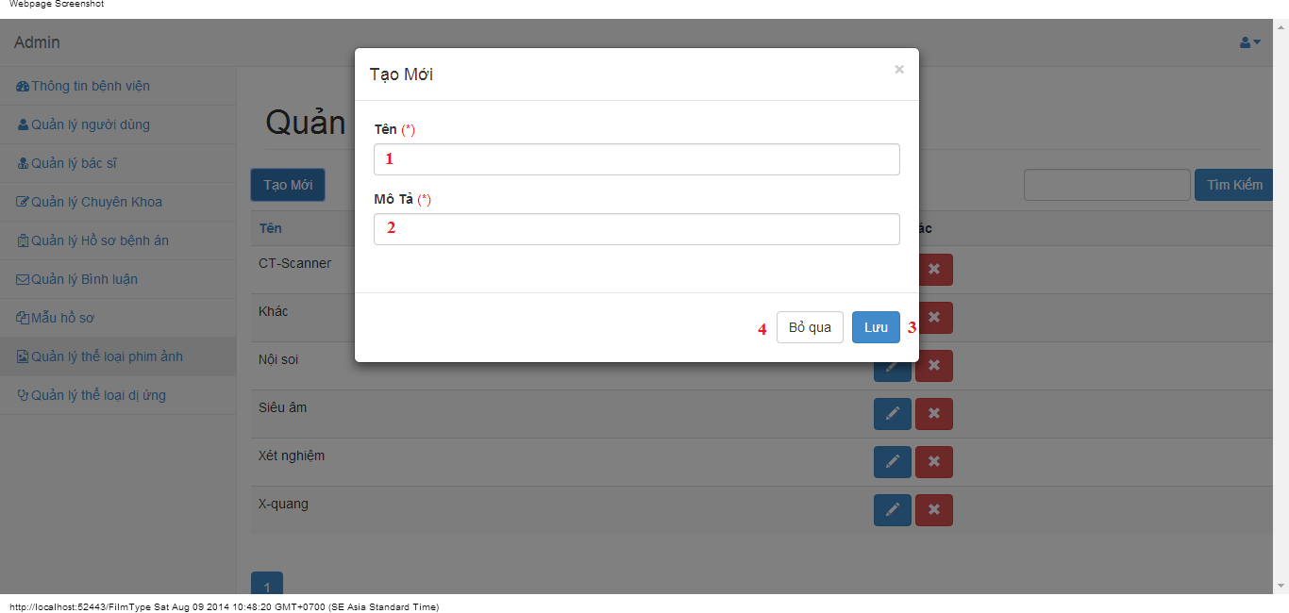

#### Objects and Actions

#### Data fields

|  |  |  |  |  |  |  |
| --- | --- | --- | --- | --- | --- | --- |
| **Field No** | **Field name** | **Type** | **Mandatory** | **Data type** | **Max length** | **Description** |
| 1 | Tên | Textbox | Yes | String | 50 | Contain film type’s name |
| 2 | Mô tả | Textbox | Yes | String | 50 | Contain film type’s description |

#### Actions

|  |  |  |  |  |  |
| --- | --- | --- | --- | --- | --- |
| **Field No** | **Field name** | **Type** | **Action** | **Description** | **Validation** |
| 9 | Lưu | Button | On click | Submit inputted data to server | Inputted data must be valid |
| 10 | Bỏ qua | Button | On click | Dismiss popup |  |

### EDIT FILM TYPE SCREEN

#### Screen image

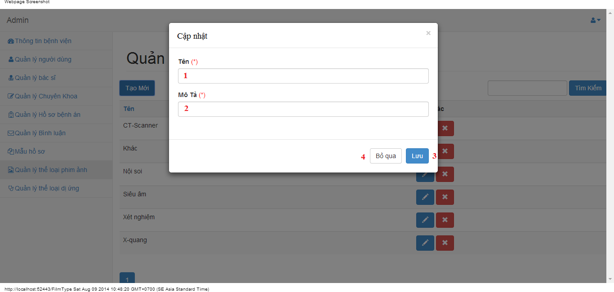

#### Objects and Actions

#### Data fields

|  |  |  |  |  |  |  |
| --- | --- | --- | --- | --- | --- | --- |
| **Field No** | **Field name** | **Type** | **Mandatory** | **Data type** | **Max length** | **Description** |
| 1 | Tên | Textbox | Yes | String | 50 | Contain film type’s name |
| 2 | Mô tả | Textbox | Yes | String | 50 | Contain film type’s description |

#### Actions

|  |  |  |  |  |  |
| --- | --- | --- | --- | --- | --- |
| **Field No** | **Field name** | **Type** | **Action** | **Description** | **Validation** |
| 9 | Lưu | Button | On click | Submit inputted data to server | Inputted data must be valid |
| 10 | Bỏ qua | Button | On click | Dismiss popup |  |

### MANAGE ALLERGY TYPES SCREEN

#### Screen image

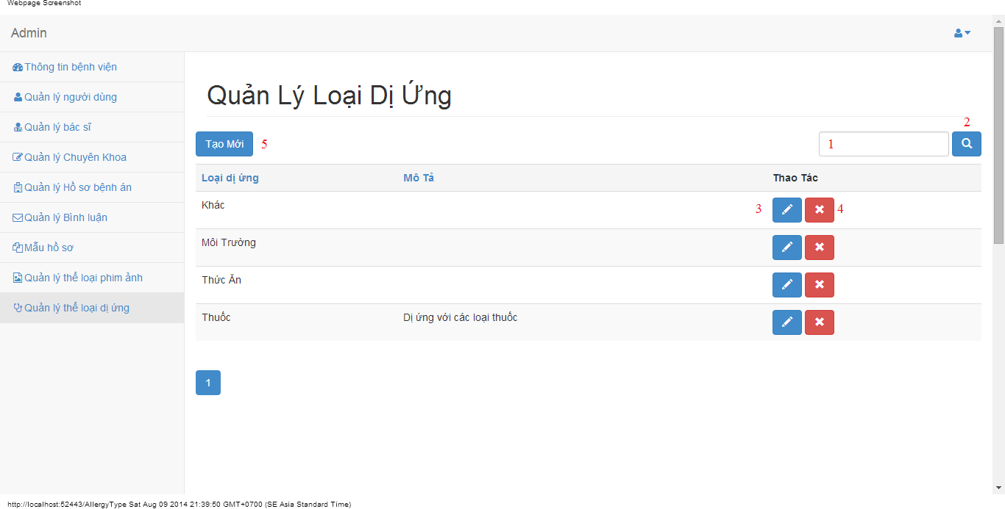

#### Objects and Actions

#### Data fields

|  |  |  |  |  |  |  |
| --- | --- | --- | --- | --- | --- | --- |
| **Field No** | **Field name** | **Type** | **Mandatory** | **Data type** | **Max length** | **Description** |
| 1 | Search | Textbox | No | String | 50 | Contain search condition to find some allergy |

#### Actions

|  |  |  |  |  |  |
| --- | --- | --- | --- | --- | --- |
| **Field No** | **Field name** | **Type** | **Action** | **Description** | **Validation** |
| 2 | Tìm | Button | On click | Send inputted search condition to server |  |
| 3 | Cập nhật | Button | On click | Forward to “Edit” page |  |
| 4 | Xóa | Button | On click | Delete an allergy type |  |
| 5 | Tạo mới | Button | On click | Forward to “Create” page |  |

### CREATE ALLERGY TYPE SCREEN

#### Screen image

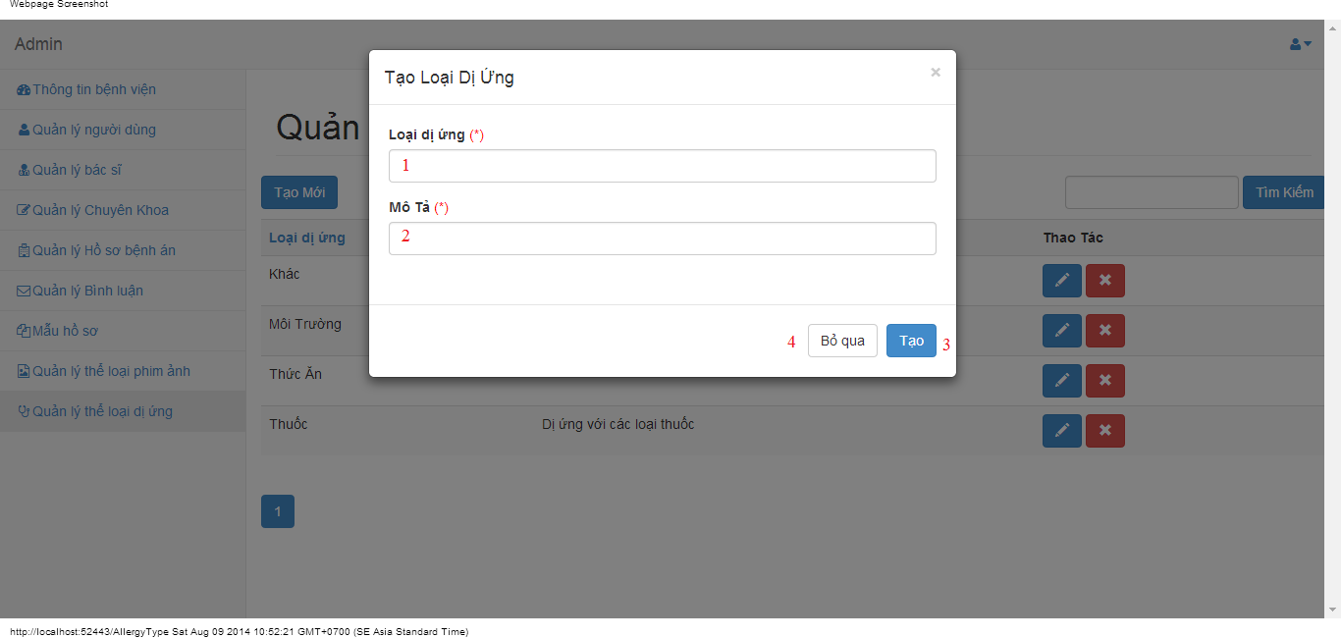

#### Objects and Actions

#### Data fields

|  |  |  |  |  |  |  |
| --- | --- | --- | --- | --- | --- | --- |
| **Field No** | **Field name** | **Type** | **Mandatory** | **Data type** | **Max length** | **Description** |
| 1 | Loại dị ứng | Textbox | Yes | String | 50 | Contain allergy type’s name |
| 2 | Mô tả | Textbox | Yes | String | 50 | Contain allergy type’s description |

#### Actions

|  |  |  |  |  |  |
| --- | --- | --- | --- | --- | --- |
| **Field No** | **Field name** | **Type** | **Action** | **Description** | **Validation** |
| 9 | Lưu | Button | On click | Submit inputted data to server | Inputted data must be valid |
| 10 | Bỏ qua | Button | On click | Dismiss popup |  |

### EDIT ALLERGY TYPE SCREEN

#### Screen image

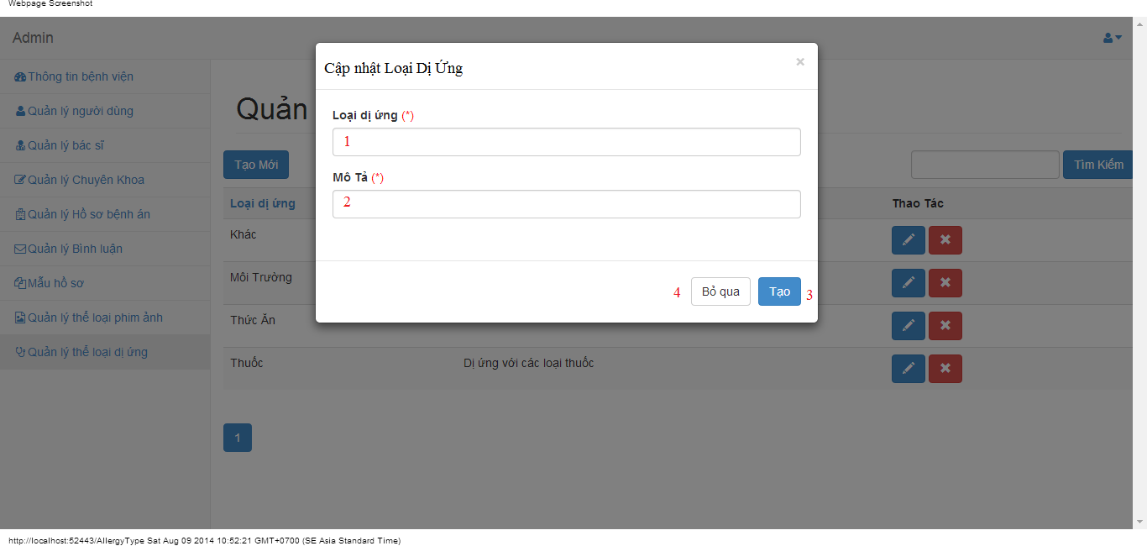

#### Objects and Actions

#### Data fields

|  |  |  |  |  |  |  |
| --- | --- | --- | --- | --- | --- | --- |
| **Field No** | **Field name** | **Type** | **Mandatory** | **Data type** | **Max length** | **Description** |
| 1 | Loại dị ứng | Textbox | Yes | String | 50 | Contain allergy type’s name |
| 2 | Mô tả | Textbox | Yes | String | 50 | Contain allergy type’s description |

#### Actions

|  |  |  |  |  |  |
| --- | --- | --- | --- | --- | --- |
| **Field No** | **Field name** | **Type** | **Action** | **Description** | **Validation** |
| 9 | Lưu | Button | On click | Submit inputted data to server | Inputted data must be valid |
| 10 | Bỏ qua | Button | On click | Dismiss popup |  |

### CHANGE PASSWORD SCREEN

#### Screen image



#### Objects and Actions

#### Data fields

|  |  |  |  |  |  |  |
| --- | --- | --- | --- | --- | --- | --- |
| **Field No** | **Field name** | **Type** | **Mandatory** | **Data type** | **Max length** | **Description** |
| 1 | Mật khẩu hiện tại | Textbox | Yes | String | 50 | Contain user’s password |
| 2 | Mật khẩu mới | Textbox | Yes | String | 50 | Contain user’s new password |
| 3 | Xác nhận mật khẩu | Textbox | Yes | String | 50 | Contain user’s re-password |

#### Actions

|  |  |  |  |  |  |
| --- | --- | --- | --- | --- | --- |
| **Field No** | **Field name** | **Type** | **Action** | **Description** | **Validation** |
| 9 | Cập nhật mật khẩu | Button | On click | Submit inputted data to server | Inputted data must be valid |
| 10 | Bỏ qua | Button | On click | Dismiss popup |  |

### MANAGE PATIENT SCREEN

#### Screen image

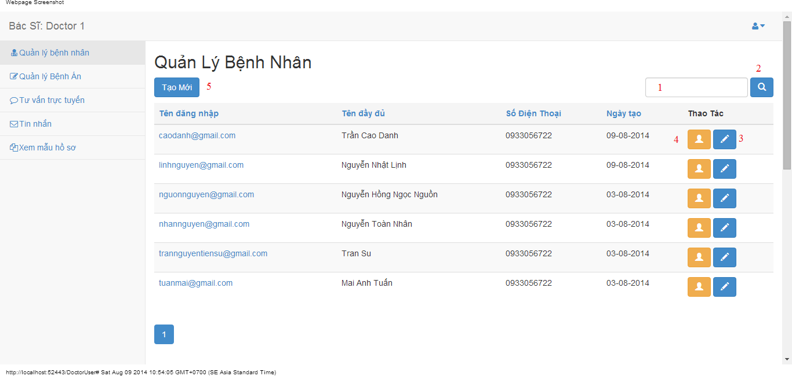

#### Objects and Actions

#### Data fields

|  |  |  |  |  |  |  |
| --- | --- | --- | --- | --- | --- | --- |
| **Field No** | **Field name** | **Type** | **Mandatory** | **Data type** | **Max length** | **Description** |
| 1 | Search | Textbox | No | String | 50 | Contain search condition to find some user account |

#### Actions

|  |  |  |  |  |  |
| --- | --- | --- | --- | --- | --- |
| **Field No** | **Field name** | **Type** | **Action** | **Description** | **Validation** |
| 2 | Tìm | Button | On click | Send inputted search condition to server |  |
| 3 | Cập nhật | Button | On click | Forward to popup “Edit” |  |
| 4 | Xem chi tiết | Link | On click | Forward to popup “View” |  |
| 5 | Tạo mới | Button | On click | Forward to popup “Create” |  |

### CREATE/EDIT PATIENT SCREEN

#### Screen image

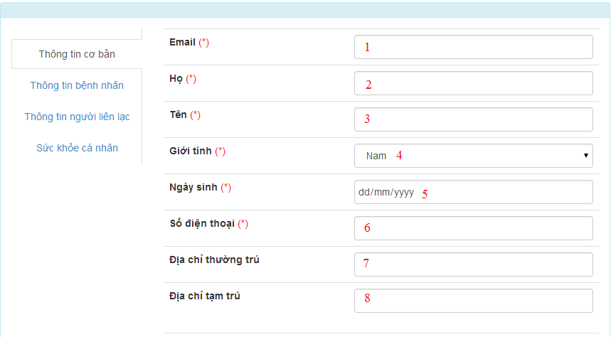









#### Objects and Actions

#### Data fields

|  |  |  |  |  |  |  |
| --- | --- | --- | --- | --- | --- | --- |
| **Field No** | **Field name** | **Type** | **Mandatory** | **Data type** | **Max length** | **Description** |
| 1 | Email | Textbox | Yes | String | 50 | Contain user’s email |
| 2 | Họ | Textbox | Yes | String | 50 | Contain user’s last name |
| 3 | Tên | Textbox | Yes | String | 50 | Contain user’s first name |
| 4 | Giới tính | Textbox | Yes | String |  | Contain user’s gender |
| 5 | Ngày sinh | Textbox | Yes | Date |  | Contain user’s birthday |
| 6 | Số điện thoại | Textbox | Yes | String | 12 | Contain user’s phone |
| 7 | Địa chỉ thường trú | Textbox | Yes | String | 50 | Contain user’s primary address |
| 8 | Địa chỉ tạm trú | Textbox | No | String | 50 | Contain user’s secondary address |
| 9 | Dân tộc | DDL | No | String | 50 | Contain user’s ethnicity |
| 10 | Quốc tịch | DDL | No | String | 50 | Contain user’s nationality |
| 11 | Công việc | Textbox | No | String | 50 | Contain user’s job |
| 12 | Nơi làm việc | Textbox | No | String | 50 | Contain user’s where to work |
| 13 | Mã số thẻ bảo hiểm y tế | Textbox | No | String | 50 | Contain user’s health insurance id |
| 14 | Ngày cấp | Textbox | No | Date | 50 | Contain user’s health insurance issued |
| 15 | Ngày hết hạn | Textbox | No | Date | 50 | Contain user’s health insurance date expired |
| 16 | Người liên lạc | Textbox | No | String | 50 | Contain user’s contact person |
| 17 | Địa chỉ người liện lạc | Textbox | No | String | 50 | Contain user’s contact person address |
| 18 | Số điện thoại người liên lạc | Textbox | No | String | 50 | Contain user’s contact person phone |
| 19 | Chiều cao | Textbox | No | String | 50 | Contain user’s height |
| 20 | Cân nặng | Textbox | No | String | 50 | Contain user’s weight |
| 21 | Màu mắt | Textbox | No | String | 50 | Contain user’s eye color |
| 22 | Màu tóc | Textbox | No | String | 50 | Contain user’s hair color |
| 23 | Nhóm máu | Textbox | No | String | 50 | Contain user’s blood type |
| 24 | Lượng đồ uống có cồn hàng tuần | Textbox | No | String | 50 | Contain user’s alcohol per week |
| 25 | Số năm uống | Textbox | No | String | 50 | Contain user’s alcohol number of year |
| 26 | Lượng thuốc hút hàng tuần | Textbox | No | String | 50 | Contain user’s smoke per week |
| 27 | Số năm hút | Textbox | No | String | 50 | Contain user’s smoke number of year |
| 28 | Tên loại thể thao | Textbox | No | String | 50 | Contain user’s sport name |
| 29 | Thời lượng tham gia hằng tuần | Textbox | No | String | 50 | Contain user’s sport per week |
| 30 | Tham gia khác | Textbox | No | String | 50 | Contain user’s exercise type |
| 31 | Thời lượng tham gia hằng tuần | Textbox | No | String | 50 | Contain user’s exercise per week |

#### Actions

|  |  |  |  |  |  |
| --- | --- | --- | --- | --- | --- |
| **Field No** | **Field name** | **Type** | **Action** | **Description** | **Validation** |
| 32 | Lưu | Button | On click | Submit inputted data to server | Inputted data must be valid |
| 33 | Bỏ qua | Button | On click | Dismiss model |  |

### VIEW PATIENT SCREEN

#### Screen image

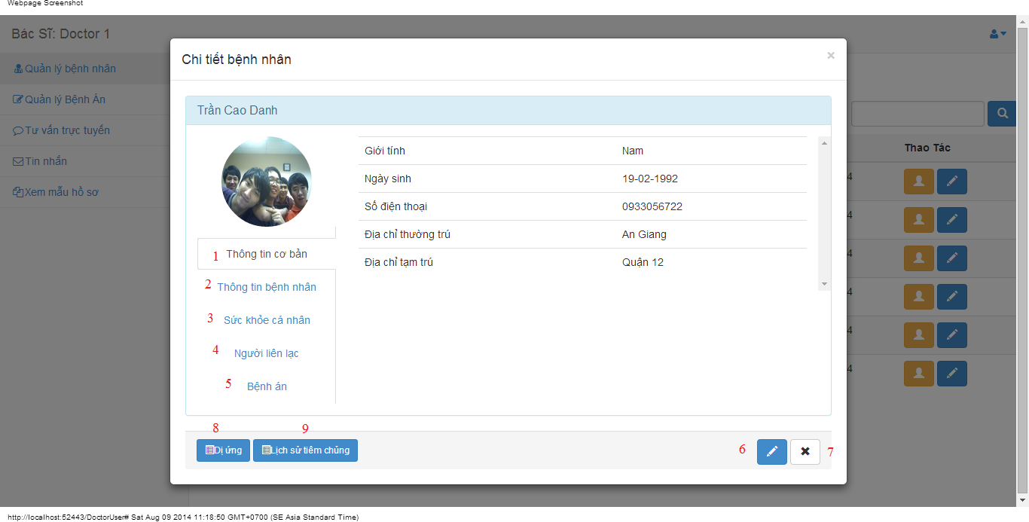

#### Objects and Actions

#### Data fields

|  |  |  |  |  |  |  |
| --- | --- | --- | --- | --- | --- | --- |
| **Field No** | **Field name** | **Type** | **Mandatory** | **Data type** | **Max length** | **Description** |

#### Actions

|  |  |  |  |  |  |
| --- | --- | --- | --- | --- | --- |
| **Field No** | **Field name** | **Type** | **Action** | **Description** | **Validation** |
| 1 | Thông tin cơ bản | Link | On click | Contain user’s basic information. |  |
| 2 | Thông tin bệnh nhân | Link | On click | Contain patient’s information. |  |
| 3 | Sức khỏe cá nhân | Link | On click | Contain user’s health record |  |
| 4 | Người liên lạc | Link | On click | Contain user’s contact person information |  |
| 5 | Bệnh án | Link | On click | Add/Edit medical profile for patient |  |
| 6 | Cập nhật | Button | On click | Forward to popup “EditPatient” |  |
| 7 | Bỏ qua | Button | On click | Dismiss modal |  |
| 8 | Dị ứng | Button | On click | Forward to popup “Allergy” |  |
| 9 | Lịch sử tiêm chủng | Button | On click | Forward to popup “Immunization” |  |

### DOCTOR COMMENT SCREEN

#### Screen image

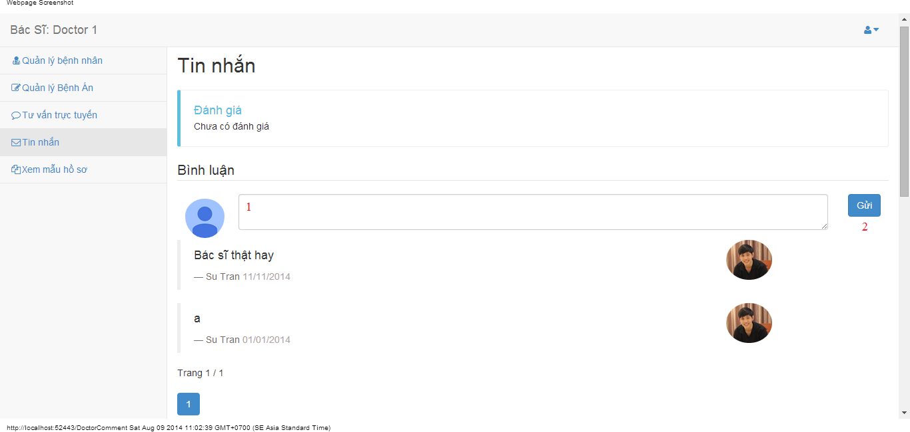

#### Objects and Actions

#### Data fields

|  |  |  |  |  |  |  |
| --- | --- | --- | --- | --- | --- | --- |
| **Field No** | **Field name** | **Type** | **Mandatory** | **Data type** | **Max length** | **Description** |
| 1 | Bình luận | Textbox | No | String |  | Comment of doctor |

#### Actions

|  |  |  |  |  |  |
| --- | --- | --- | --- | --- | --- |
| **Field No** | **Field name** | **Type** | **Action** | **Description** | **Validation** |
| 2 | Gửi | Button | On click | Summit inputted data to server |  |

### DOCTOR CONVERSATION SCREEN

#### Screen image

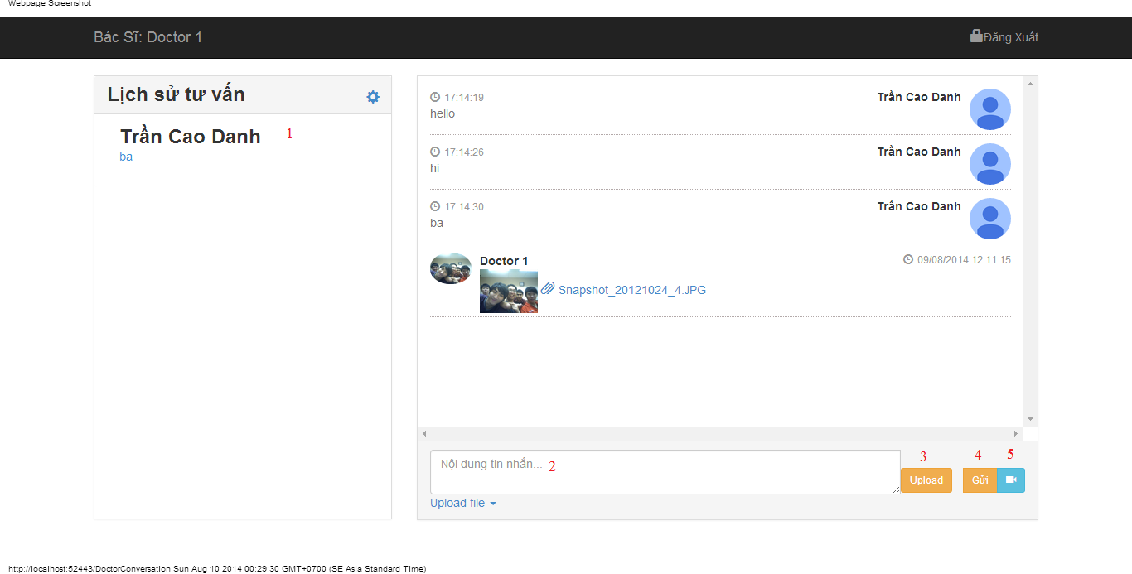

#### Objects and Actions

#### Data fields

|  |  |  |  |  |  |  |
| --- | --- | --- | --- | --- | --- | --- |
| **Field No** | **Field name** | **Type** | **Mandatory** | **Data type** | **Max length** | **Description** |
| 2 | Nội dung tin nhắn | Textbox | No | String |  | Contain user’s content conversation |

#### Actions

|  |  |  |  |  |  |
| --- | --- | --- | --- | --- | --- |
| **Field No** | **Field name** | **Type** | **Action** | **Description** | **Validation** |
| 1 | Lịch sử tư vấn | Link | On click | Click on a patient to chat |  |
| 3 | Upload | File | On click | Submit inputted file to server |  |
| 4 | Gửi | Button | On click | Submit inputted data to server |  |
| 5 | Yêu cầu xem webcam | Button | On click | Request webcam to patient |  |

### DOCTOR INFORMATION SCREEN

#### Screen image

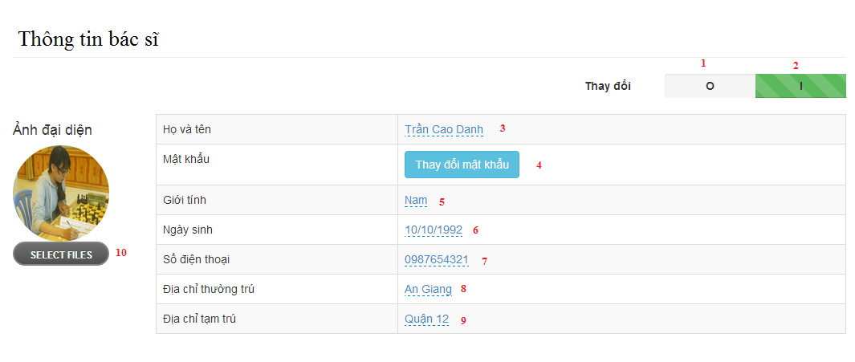

#### Objects and Actions

#### Data fields

|  |  |  |  |  |  |  |
| --- | --- | --- | --- | --- | --- | --- |
| **Field No** | **Field name** | **Type** | **Mandatory** | **Data type** | **Max length** | **Description** |
| 3 | Họ và tên | Textbox | Yes | String | 50 | Contain user’s full name |
| 5 | Giới tính | List | Yes | String | 50 | Contain user’s gender |
| 6 | Ngày sinh | Textbox | Yes | Date | 12 | Contain user’s birthday |
| 7 | Số điện thoại | Textbox | Yes | String | 12 | Contain user’s phone |
| 8 | Địa chỉ thường trú | Textbox | Yes | String | 50 | Contain user’s primary address |
| 9 | Địa chỉ tạm trú | Textbox | No | String | 50 | Contain user’s secondary address |

#### Actions

|  |  |  |  |  |  |
| --- | --- | --- | --- | --- | --- |
| **Field No** | **Field name** | **Type** | **Action** | **Description** | **Validation** |
| 1 | 0 | Checkbox | On click | Click “0” to view table admin information |  |
| 2 | I | Checkbox | On click | Click “I” to edit table data admin information |  |
| 4 | Thay đổi mật khẩu | Button | On click | Forward to popup “ChangePassword” |  |
| 10 | Chọn tệp | File | On click | Submit inputted file to server |  |

### PATIENT INFORMATION SCREEN

#### Screen image

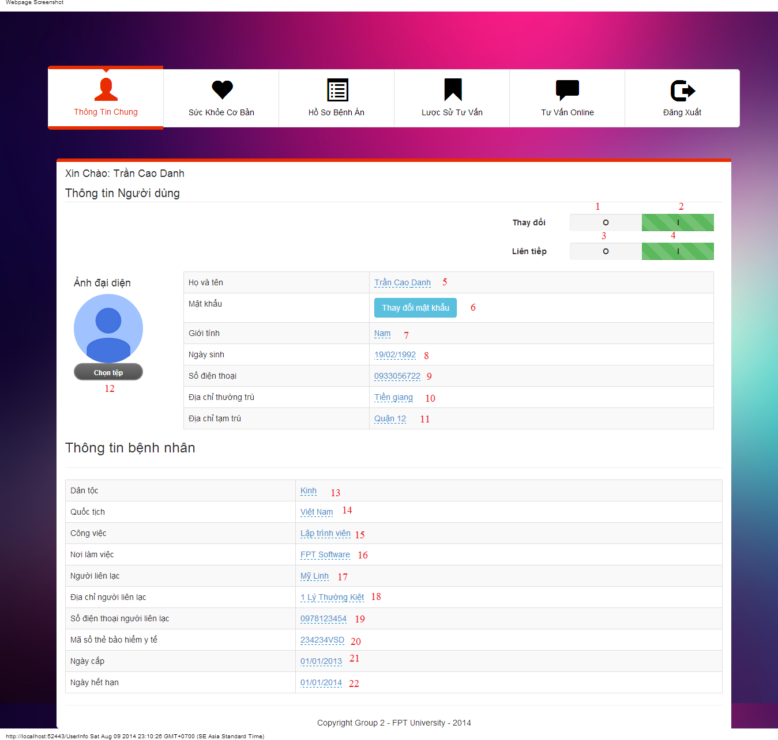

#### Objects and Actions

#### Data fields

|  |  |  |  |  |  |  |
| --- | --- | --- | --- | --- | --- | --- |
| **Field No** | **Field name** | **Type** | **Mandatory** | **Data type** | **Max length** | **Description** |
| 5 | Họ Tên | Textbox | Yes | String | 50 | Contain user’s full name |
| 7 | Giới tính | Textbox | Yes | String |  | Contain user’s gender |
| 8 | Ngày sinh | Textbox | Yes | Date |  | Contain user’s birthday |
| 9 | Số điện thoại | Textbox | Yes | String | 12 | Contain user’s phone |
| 10 | Địa chỉ thường trú | Textbox | Yes | String | 50 | Contain user’s primary address |
| 11 | Địa chỉ tạm trú | Textbox | No | String | 50 | Contain user’s secondary address |
| 12 | Dân tộc | DDL | No | String | 50 | Contain user’s ethnicity |
| 13 | Quốc tịch | DDL | No | String | 50 | Contain user’s nationality |
| 14 | Công việc | Textbox | No | String | 50 | Contain user’s job |
| 15 | Nơi làm việc | Textbox | No | String | 50 | Contain user’s where to work |
| 20 | Mã số thẻ bảo hiểm y tế | Textbox | No | String | 50 | Contain user’s health insurance id |
| 21 | Ngày cấp | Textbox | No | Date | 50 | Contain user’s health insurance issued |
| 22 | Ngày hết hạn | Textbox | No | Date | 50 | Contain user’s health insurance date expired |
| 18 | Người liên lạc | Textbox | No | String | 50 | Contain user’s contact person |
| 19 | Địa chỉ người liện lạc | Textbox | No | String | 50 | Contain user’s contact person address |
| 20 | Số điện thoại người liên lạc | Textbox | No | String | 50 | Contain user’s contact person phone |

#### Actions

|  |  |  |  |  |  |
| --- | --- | --- | --- | --- | --- |
| **Field No** | **Field name** | **Type** | **Action** | **Description** | **Validation** |
| 1 | 0 | Checkbox | On click | Click “0” to view table admin information |  |
| 2 | I | Checkbox | On click | Click “I” to edit table data admin information |  |
| 3 | O | Checkbox | On click | Click “0” to not next value after 300 second |  |
| 4 | I | Checkbox | On click | Click “0” to next value after 300 second |  |
| 6 | Thay đổi mật khẩu | Button | On click | Forward to popup “ChangePassword” |  |
| 12 | Chọn tệp | File | On click | Submit inputted file to server |  |

### PATIENT HEALTH RECORD SCREEN

#### Screen image

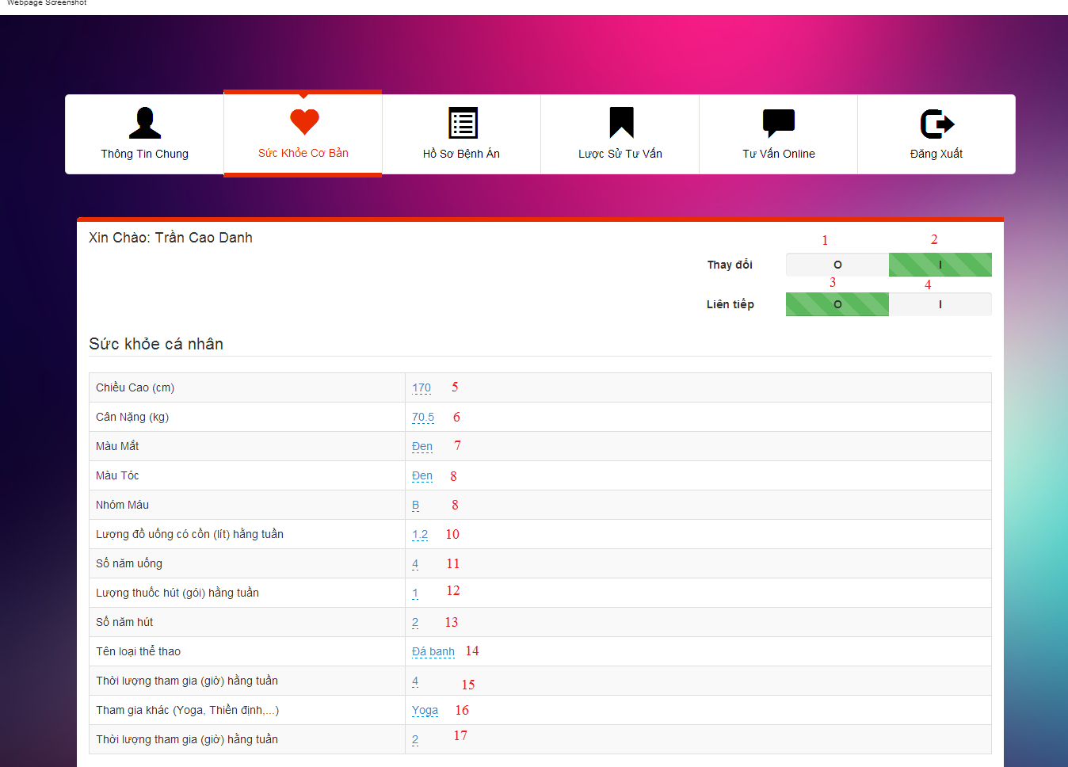

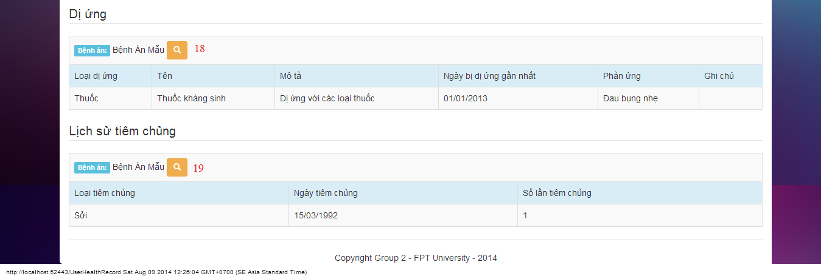

#### Objects and Actions

#### Data fields

|  |  |  |  |  |  |  |
| --- | --- | --- | --- | --- | --- | --- |
| **Field No** | **Field name** | **Type** | **Mandatory** | **Data type** | **Max length** | **Description** |
| 5 | Chiều cao | Textbox | No | String | 50 | Contain user’s height |
| 6 | Cân nặng | Textbox | No | String | 50 | Contain user’s weight |
| 7 | Màu mắt | Textbox | No | String | 50 | Contain user’s eye color |
| 8 | Màu tóc | Textbox | No | String | 50 | Contain user’s hair color |
| 9 | Nhóm máu | Textbox | No | String | 50 | Contain user’s blood type |
| 10 | Lượng đồ uống có cồn hàng tuần | Textbox | No | String | 50 | Contain user’s alcohol per week |
| 11 | Số năm uống | Textbox | No | String | 50 | Contain user’s alcohol number of year |
| 12 | Lượng thuốc hút hàng tuần | Textbox | No | String | 50 | Contain user’s smoke per week |
| 13 | Số năm hút | Textbox | No | String | 50 | Contain user’s smoke number of year |
| 14 | Tên loại thể thao | Textbox | No | String | 50 | Contain user’s sport name |
| 15 | Thời lượng tham gia hằng tuần | Textbox | No | String | 50 | Contain user’s sport per week |
| 16 | Tham gia khác | Textbox | No | String | 50 | Contain user’s exercise type |
| 17 | Thời lượng tham gia hằng tuần | Textbox | No | String | 50 | Contain user’s exercise per week |

#### Actions

|  |  |  |  |  |  |
| --- | --- | --- | --- | --- | --- |
| **Field No** | **Field name** | **Type** | **Action** | **Description** | **Validation** |
| 1 | 0 | Checkbox | On click | Click “0” to view table admin information |  |
| 2 | I | Checkbox | On click | Click “I” to edit table data admin information |  |
| 3 | O | Checkbox | On click | Click “0” to not next value after 300 second |  |
| 4 | I | Checkbox | On click | Click “0” to next value after 300 second |  |
| 18 | Bệnh án mẫu | Button | On click | Forward to “Details” medical profile page |  |
| 19 | Bệnh án mẫu | Button | On click | Forward to “Details” medical profile page |  |

### MEDICAL PROFILE SCREEN

#### Screen image

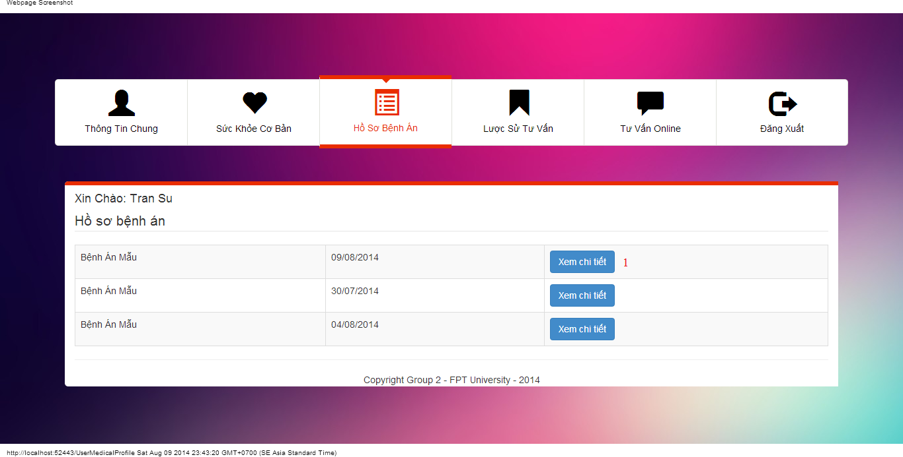

#### Objects and Actions

#### Data fields

|  |  |  |  |  |  |  |
| --- | --- | --- | --- | --- | --- | --- |
| **Field No** | **Field name** | **Type** | **Mandatory** | **Data type** | **Max length** | **Description** |

#### Actions

|  |  |  |  |  |  |
| --- | --- | --- | --- | --- | --- |
| **Field No** | **Field name** | **Type** | **Action** | **Description** | **Validation** |
| 1 | Xem chi tiết | Button | On click | Forward to “Details” medical profile page |  |

### VIEW CONSULT HISTORY SCREEN

#### Screen image

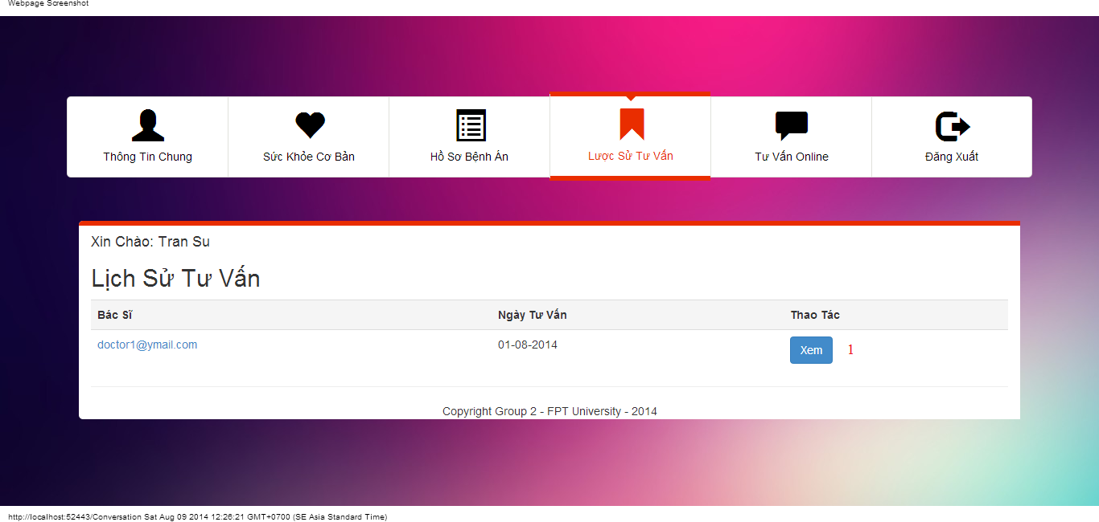

#### Objects and Actions

#### Data fields

|  |  |  |  |  |  |  |
| --- | --- | --- | --- | --- | --- | --- |
| **Field No** | **Field name** | **Type** | **Mandatory** | **Data type** | **Max length** | **Description** |

#### Actions

|  |  |  |  |  |  |
| --- | --- | --- | --- | --- | --- |
| **Field No** | **Field name** | **Type** | **Action** | **Description** | **Validation** |
| 1 | Xem | Button | On click | Forward to “ConversationDetails” page |  |

### USER CONVERSATION SCREEN

#### Screen image

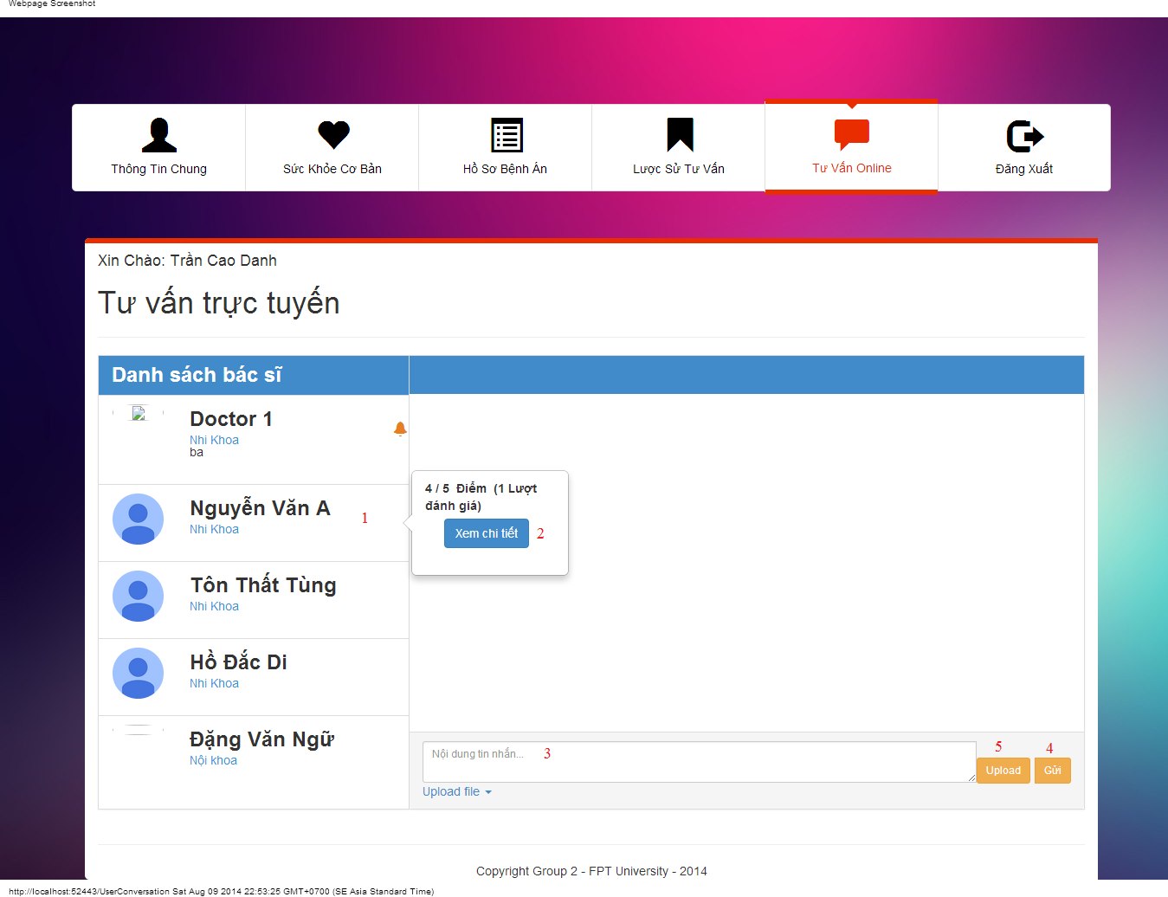

#### Objects and Actions

#### Data fields

|  |  |  |  |  |  |  |
| --- | --- | --- | --- | --- | --- | --- |
| **Field No** | **Field name** | **Type** | **Mandatory** | **Data type** | **Max length** | **Description** |
| 3 | Nội dung tin nhắn | Textbox | No | String |  | Contain user’s content conversation |

#### Actions

|  |  |  |  |  |  |
| --- | --- | --- | --- | --- | --- |
| **Field No** | **Field name** | **Type** | **Action** | **Description** | **Validation** |
| 1 | Danh sách bác sĩ | Link | On click | Click on a doctor to chat |  |
| 2 | Xem chi tiết | Button | On click | Forward to “Comment” page |  |
| 4 | Gửi | Button | On click | Submit inputted data to server |  |
| 5 | Upload | File | On click | Submit inputted file to server |  |

### USER COMMENT/RATING SCREEN

#### Screen image

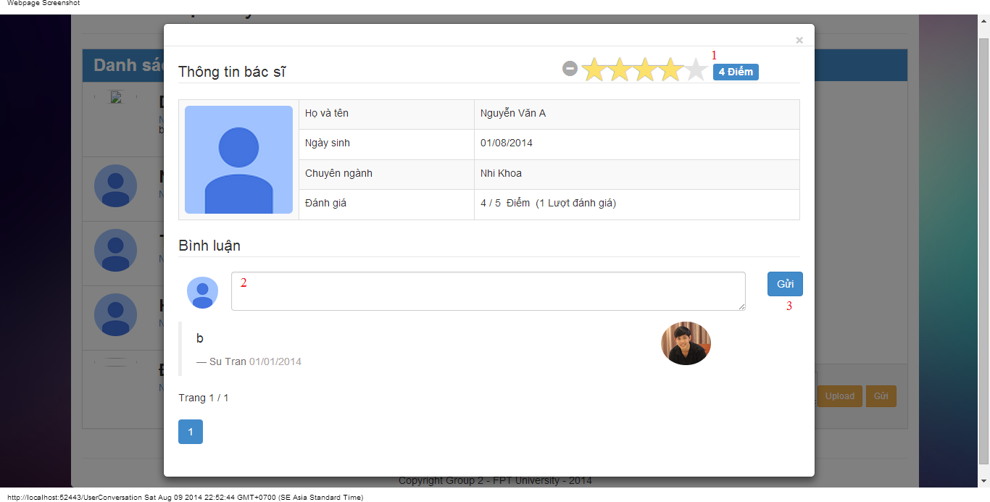

#### Objects and Actions

#### Data fields

|  |  |  |  |  |  |  |
| --- | --- | --- | --- | --- | --- | --- |
| **Field No** | **Field name** | **Type** | **Mandatory** | **Data type** | **Max length** | **Description** |
| 2 | Bình luận | Textbox | No | String |  | Comment of user |

#### Actions

|  |  |  |  |  |  |
| --- | --- | --- | --- | --- | --- |
| **Field No** | **Field name** | **Type** | **Action** | **Description** | **Validation** |
| 1 | Điểm | Button | On click | Summit inputted rate to server |  |
| 3 | Gửi | Button | On click | Summit inputted data to server |  |

## Database Design

